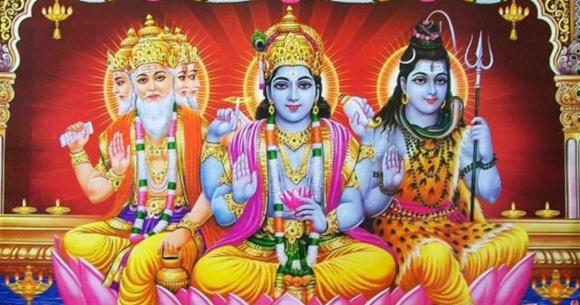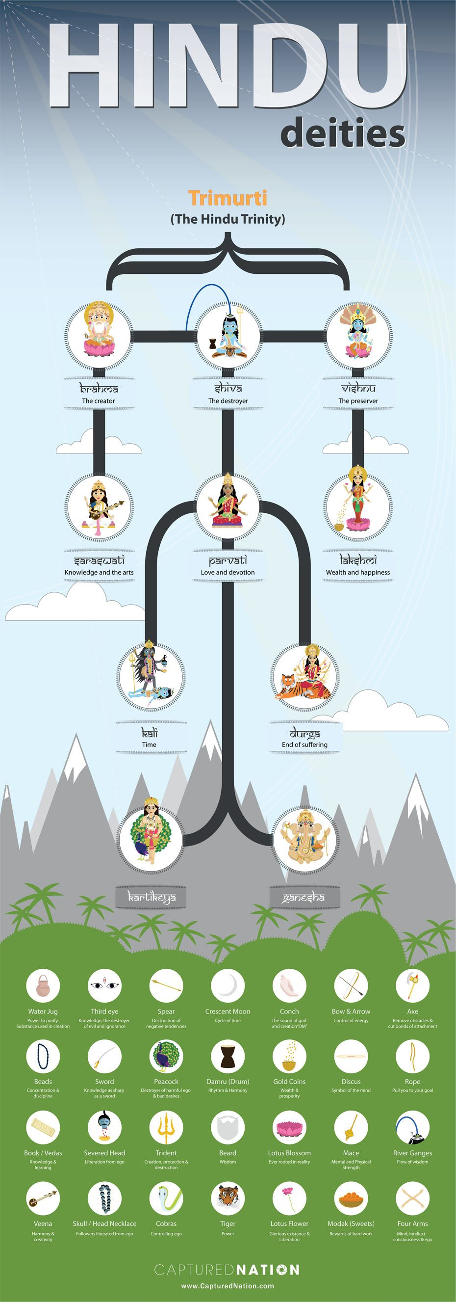

**Key Figures/Features:**

. **Brahma -** The god of creation. He has four arms and four faces, looking in the four directions.

**. Vishnu -** The god of preservation and protection. Hindus believe that he returns to earth during troubled times to restore the balance between good and evil.

**. Shiva -** The god of destruction.

**Key Vocabulary:**

**. Hindu/Hinduism –** The oldest religion in the world. Scholars regard Hinduism as a combination of different Indian cultures and traditions.

. **Aum or Om** - The most sacred symbol in Hinduism.

**. Brahman** – The Ultimate Reality of Universe in Hinduism.

**. Diwali** - A festival of lights and Hindus celebrate it with joy. During this festival, people light up their houses and shops with Diyas (small cup-shaped oil lamp made of baked clay).

**. Mandir** – A dwelling place.

**. Offering** – A contribution to the gods for a certain purpose.

**. Pray** – A way of speaking to the gods, where they always listen.

**. Shrine** – A holy or sacred place with something important inside it.

**. Worship** - Deep respect toward God, a god, or a sacred object.

**RE Knowledge Organiser**

**Hindu Deities and Hindu Beliefs**

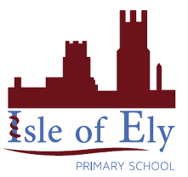

Key figures: