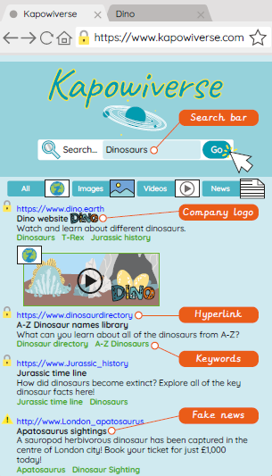

**Key Figures/Features:**

. **Algorithm** – A sequence of instructions which, when followed, solves a problem.

**. Company Logo** – A symbol used to represent an organisation, so that it can be identified quickly and easily both online and in the real world.

**. Data Leak** – When information is released without approval from the owner or creator.

**. Data Privacy** – The right to keep information private and away from those you do not wish to have access.

**. Fake News** – False and inaccurate information that is shared in a convincing way, usually on social media and websites.

**. Inaccurate Information** – When information is false or untrue.

**. Index** – A computer saves key information about previously searched results, to make this quicker next time they are accessed.

**. Keywords (internet)** – A set of words used to define and produce an accurate search engine result.

**. Network** – When more than one electronic device is connected in a network through the internet in order to share files and information.

**. Online** – When a person is accessing the internet through an electronic device.

**. Page Rank** – Web pages are sorted in an order to give the user the most suitable results at the top of the list.

**. Search Engine** – A way for a user to search the internet’s database of information.

**. TASK** – Title, Author, Summary, Kids

**. Web Crawler** – A program that uses keywords to search the WWW in a logical way to find the most suitable results for the user.

**. Website** – A series of web pages and other content, which can be discovered and read through an internet browser.

**. WWW** – The acronym used to express the ‘World Wide Web’. It is found at the beginning of web addresses.

**Computing Knowledge Organiser**

**Search Engines**



Key figures: