**Key Facts:**

. The period of growth and change from eight to seventeen, between childhood and adulthood, is known as adolescence. During this time, boys and girls go through puberty.  
. Metabolism is the rate at which your body converts food to energy. As you get older your metabolism slows down.  
. Hormones are chemicals released in the body by glands. There are two types of glands – duct and ductless.

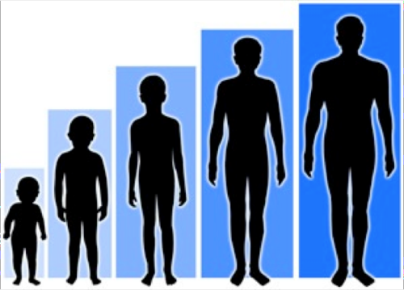

**Key Vocabulary:**

**Foetus** – An unborn human more than eight weeks after conception.

**Gestation Period** – The time in which a foetus develops, beginning with fertilization and ending at birth. It lasts nine months in humans.

**Adolescence** – The period following the onset of puberty during which a young person develops from a child into an adult.

**Puberty** – The period during which adolescents reach sexual maturity and become capable of reproduction.

**Hormone** – A chemical released in a gland that travels to other parts of the body where it helps control how cells and organs do their work.

**Growth Stage** – Infancy, childhood, adolescence, and adulthood are human growth stages before old age.

**Science Knowledge Organiser**

**The Human Body**



Key figures: