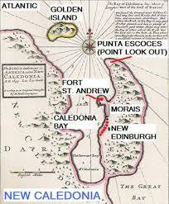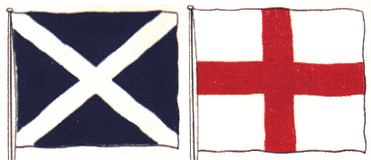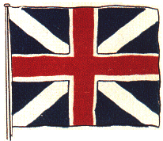

**Key Figures:**

. **James I –**

The First Stuart king, originally Charles IV of Scotland.

. William Paterson –

Merchant who suggested the colony location.

. **Queen Anne** and Queen Mary –

Current reigning monarch, Mary was Anne’s Sister.

. **Electress Sophia of Hanover –**

Proposed successor to the throne.

. **George I –**

Queen Anne’s second cousin and first Hanoverian ruler of Britain.

. Robert Burns –

A Scottish Poet.

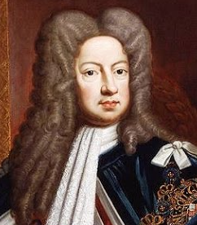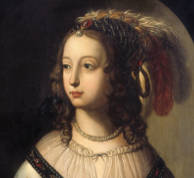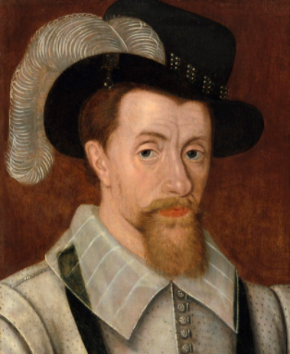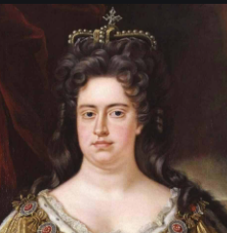

**Key Vocabulary:**

**Union** – A society or association formed by people with a common interest or purpose.

**Darien** – A province in eastern Panama, partially bounded by Colombia and the Pacific Ocean.

**Colony/Colonists** – A territory occupied by settlers of another state. A colonist is someone who helps start a settlement in a new land.

**Succession** – The process of inheriting a title, office or property,

**Bankrupt** – Unable to pay debts.

**Taxation** – Money paid as tax.

**Mutual Hostility** – An unfriendly or warlike feeling between two groups or people.

**Mutual Mistrust** - The feeling that you have towards someone who you do not trust.

**History Knowledge Organiser**

**18th Century Union of Britain**

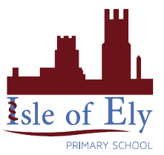

Key figures: