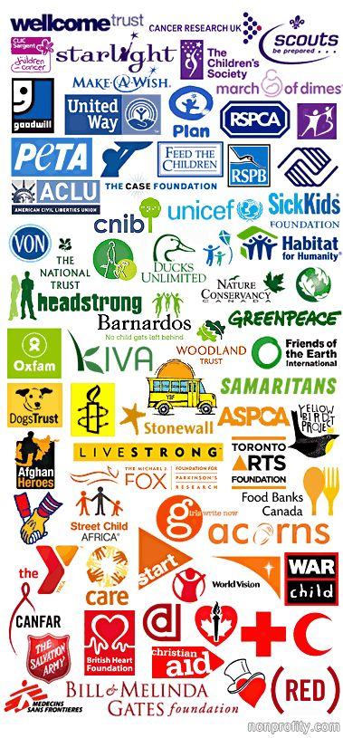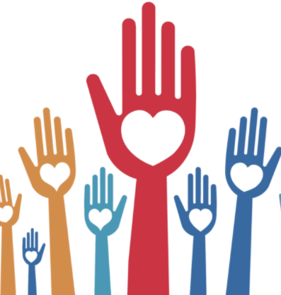

**Key Vocabulary:**

Charity – Voluntary giving of help.

Faith/belief – Trust and confidence in something or someone.

Sacrifice – Give up (something valued) for the sake of other consideration.

Zakat – The third pillar of Islam meaning charity.

Mosque – A place of worship for Muslims

Moral – Knowing what is right or wrong and acting on this.

**Charities in the UK**

Oxfam

Muslim Aid

Christian Aid

Fairtrade

Islamic Relief

**RE Knowledge Organiser**

**Charities and Helping the Poor**

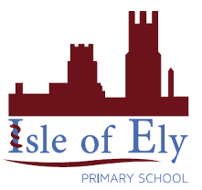

Key figures: