**Key Vocabulary:**

Form

3D

Height

Width

Depth

Organic

Symmetrical

Asymmetrical

Light

Shadow

Attention

Chiaroscuro

Mood

Feeling

Symmetry

Line of symmetry

Pattern

Overlapping

Placement

Foreground

Middle ground

Background

**Art Knowledge Organiser**

**Form, Symmetry, Light Space and Design**

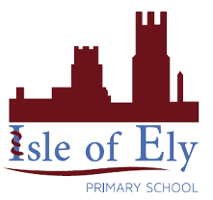

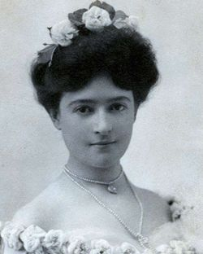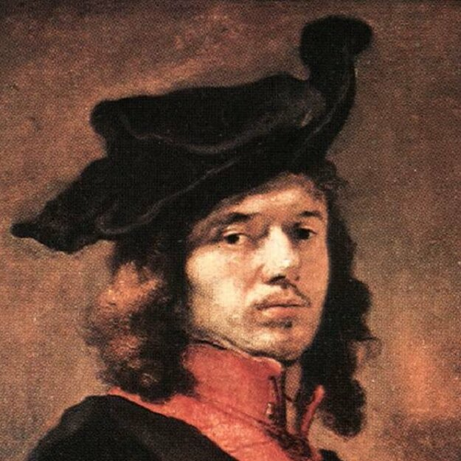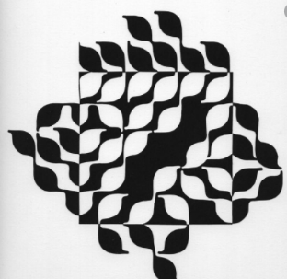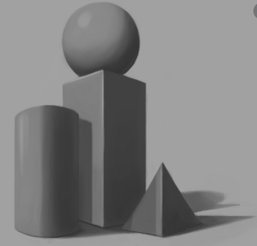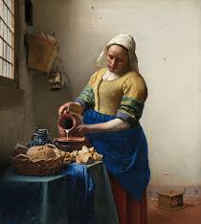

**Clara Driscoll**

**Key Facts:**

. **Symmetry** focuses on making two sides exactly the same. However, **Asymmetric** is where the two sides are the same.

. The **foreground** is the closest position in a picture.

. The **mid ground** is the middle of the picture.

. The **background** is the furthest part away in a picture.

. **Chiaroscuro** is an Italian term that means ‘light dark’. This usually focuses on the foreground being light and the background dark.

**Johannes Vermeer**

Key figures: