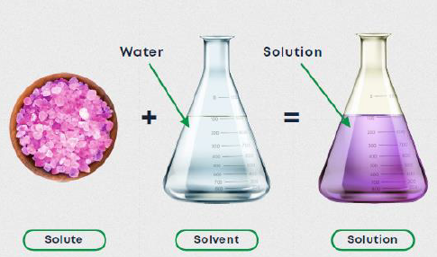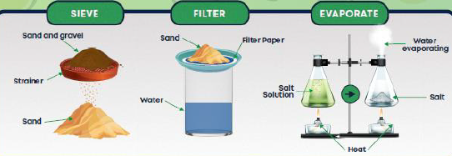

**Properties of materials:**

. transparent . opaque

. shiny . dull

. insulator . conductor

. hard . soft

. soluble . insoluble

. strong . weak

. flexible

**Key Vocabulary:**

**Physical Property** – Something that can be observed and measured for a material (hardness, shininess, conductivity).

**Mixture** – Two or more materials that can be separated.

**Dissolved** – When something mixes and blends well with a liquid.

**Solvent** – The liquid that something dissolves in.

**Solute** – The material that dissolves in the solvent.

**Saturated** – When no more of a solute can dissolve in a solvent.

**Reversible Change** – A change that can be reversed so the material goes back to how it was.

**Evaporation** – When a liquid changed state to a gas.

**Filtering** – Removing solids from a mixture by passing through paper that only allows liquid through.

**Science Knowledge Organiser**

**Materials**



Key figures: