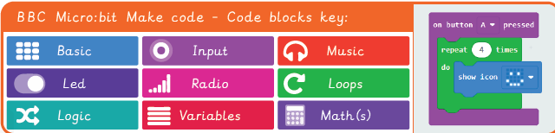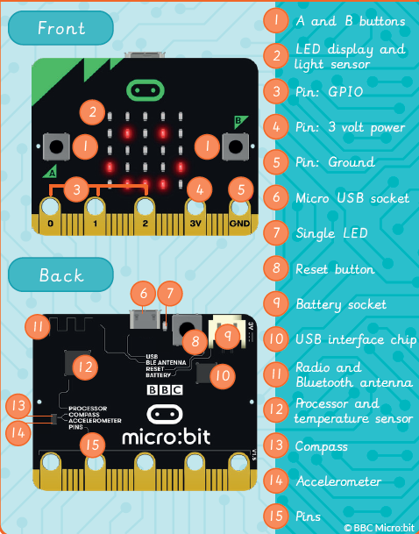

**Key Figures/Features:**

. **.hex file** – A file type that carries binary information.

**. .zip file** – Multiple files that are bound together as a single file, to use less digital storage space.

**. Bluetooth** – Device to device connectivity, for example sharing images between two smart phones.

**. Code blocks** – A visual representation for a section of code that performs a certain job. They can be snapped together to build a program.

**. Decompose** – To break something down into smaller chunks.

**. Emulator** – A program or machine that is built to copy the way another computer system works.

**. Feature** – Distinctive characteristics of something.

**. Loop**– A repeated sequence of instructions.

**. Micro : bit** – Created by the BBC, a small compact computer that you can code.

**. Pedometer** – A device used to record the number of steps taken to calculate the distance travelled.

**. Predict** – To make an educated guess, as to what might happen or occur as the result of something in the future.

**. Systematic** – Doing something in an ordered way to achieve a specified goal.

**. Tinker** – To explore and play with something to discover the key functions.

**. Variable** – This could be a number or text, that can changed each time the program is run and often in combination with selection to change the end result of the program.

**Computing Knowledge Organiser**

**Micro:Bit**



Key figures: