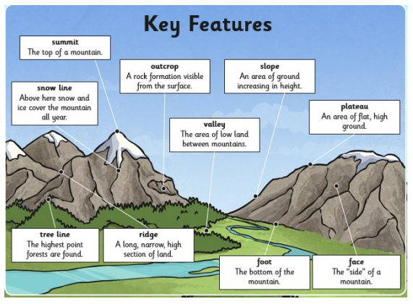 v

**Key Vocabulary:**

**Peak –** The pointed top of a mountain.

**Range –** A set of different things of the same general type.

**Contour –** Lines drawn on a map to show changes in levels.

**Elevation -** A contour line on a map that shows height.

**Depression -** A contour line on a map that shows the depth below the surface.

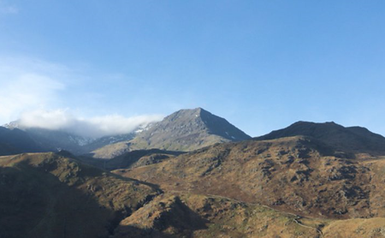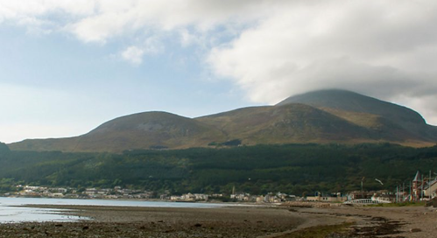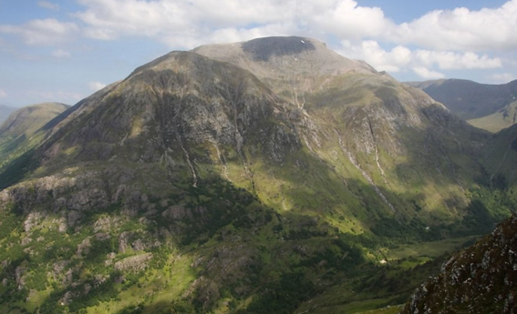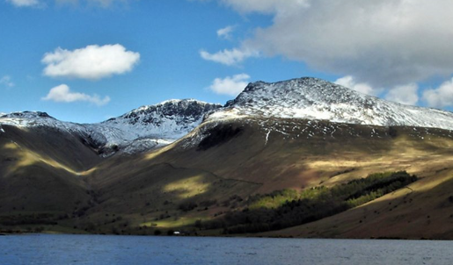

**Famous Mountains:**

**The Cairngorms –** A mountain range in Scotland, Ben Nevis can be found here and is the tallest mountain in Scotland (1,345m).

**The Pennines –** A mountain range in England, Scafell Pike can be found here and is the tallest mountain in England (978m).

**The Mourne Mountains –** A mountain range in Northern Ireland, Slieve Donard can be found here and is the tallest mountain in Northern Ireland (850m).

**Snowdonia -** A mountain range in Wales, Snowdon can be found here and is the tallest mountain in Wales (1085m).

**Geography Knowledge Organiser**

**Mountains**

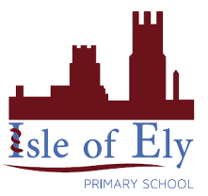

Key figures: