Vocabulary:
Binary code | A code used in computers, based around the binary values of 0 and 1.
Data | Information used for a specific purpose or investigation.
Data transmission | The movement of information from one or more points to another.
Discovery | When something is intentionally or unintentionally found.
Distance | The amount of space between two places or objects.
Input | Information sent to a computer by an input device such as a keyboard or mouse for processing.
Mars Rover | A robotic vehicle, that explores, investigates and returns data about the terrain on Mars.
Numerical data | Information that is based on numbers and digits.
Output | Information or data that is sent by the computer to an output device such as a printer or speakers.
Radio signal | A radio wave that is sent or received to somewhere.
Scientist | A person who studies within the fields of Science, such as Physics, Biology and Chemistry.
Sequence | A set order or pattern for something to follow.
Signal | A voltage, current or electromagnetic wave that is either sent or obtained.
Computer simulation | Computer generated imitation of something such as a program test or a product prototype.
Space (astronomy) | A vast area around and beyond planet Earth, which is not inhabited.
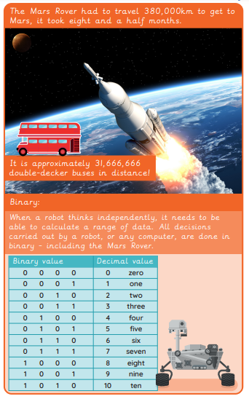
Unit: Mars Rover 1
Term: Summer A
Key figures:

