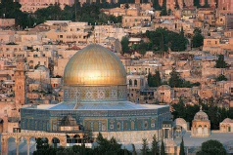
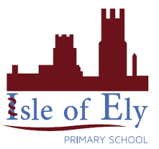
Architecture:
. The Dome of the Rock (Jerusalem).
. The Taj Mahal (Agra, India).
Art Knowledge Organiser
Islamic Art

Key Vocabulary | Definition
Islamic art/architecture | Art or architecture which relates to the religion of Islam or the Islamic world.
Mosque | A place of worship for Muslims.
Minaret | A thin tower, usually part of a mosque, from which a person calls Muslims to prayer.
Dome | The hollow, upper half of a sphere, often used in Islamic architecture.
Calligraphy | Decorative handwriting.
Geometric patterns | A pattern made out of geometric shapes such as triangles, squares, circles.
Vegetal patterns | A pattern made out of shapes and lines which represent plants.
Figural | Art work showing humans or animals.

Key figures:
