Key Vocabulary | Definition
Peace | Freedom from disturbance: tranquillity. A state or period in which there is no war or a war has ended.
Cohesion | The action or fact of forming a united whole.
Community | A group of people living in the same place or having a particular characteristic in common.
Inner Peace | A state of being mentally and spiritually at peace, with enough knowledge and understanding to keep oneself strong in the face of stress
RE Knowledge Organiser
Promotion of Peace

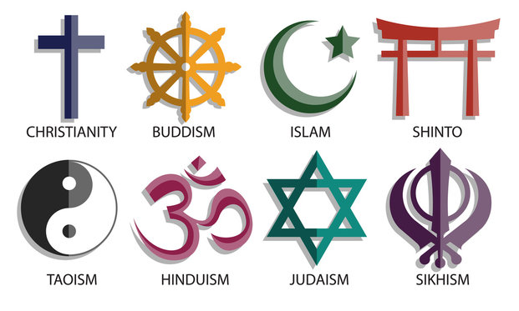

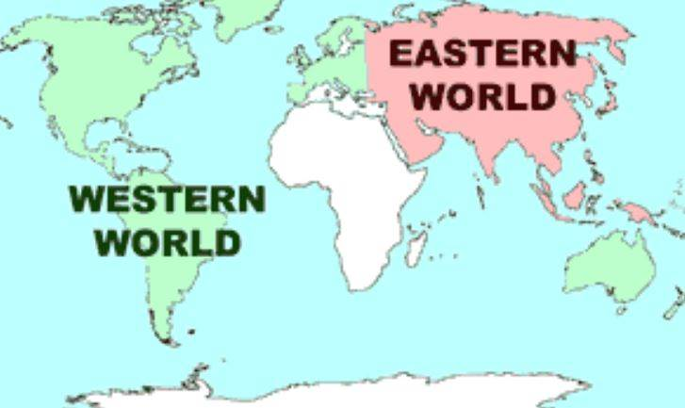
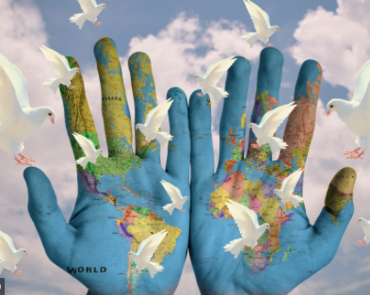
Key Religions
Hinduism Buddhism Christianity
Islam Sikhism Judaism

