Vocabulary:
Revolution | A time when people overthrow the rulers and try to change how people live and work.
Absolute Monarchy | When a King or Queen is in complete control and doesn’t need to follow any rules or laws.
Republic | A country governed by elected representatives, not by a King or Queen.
Clergy | People who have a role within the Church, e.g. Catholic Priest
Nobles | Wealthy people from families who are considered important.
Exile | When a person is banned from living in a country, often used as a punishment.
Bastille | A prison in Paris used by French Kings.
Learning Links:
Prior Learning: | Future Learning:
Overthrow – Year 4  Execution of Charles I and the Commonwealth | Overthrow – Year 6 The Rise of Nazi Germany
Monarchy – Year 3 The War of the Roses and Henry VII
Execution – Year 1 Kings and Queens | Revolt - Year 5 Abolitionism
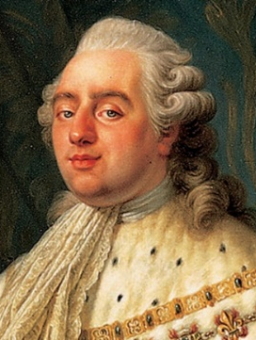
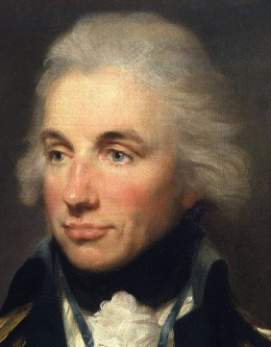
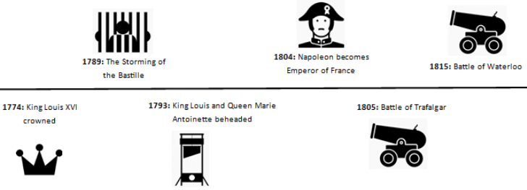
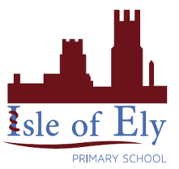
Marie Antoinette
Napoleon
King Louis XVI
Horatio Nelson
Timeline
Unit: The French Revolution
Term: Summer A

