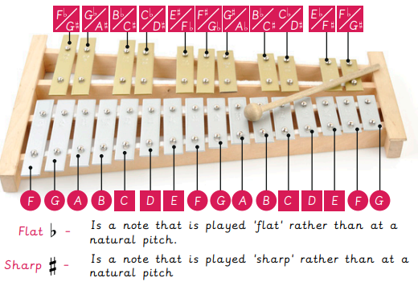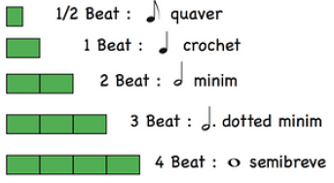

**Improvisation**

**Quaver**

**Bar**

**Bent Notes**

**Blues Scale**

**Descending Scale**

**Ascending Scale**

**Scale**

**Chord**

**12 Bar Blues – A series of chords played in a specific order.**

**Blues music is often sad and emotional, which is why we say we have 'the blues' when we feel sad. Its main features are the 12-bar blues and the blues scale, and it includes a lot of improvisation.**

**Instruments**

**Music Knowledge Organiser**

**The Blues**



Key figures: