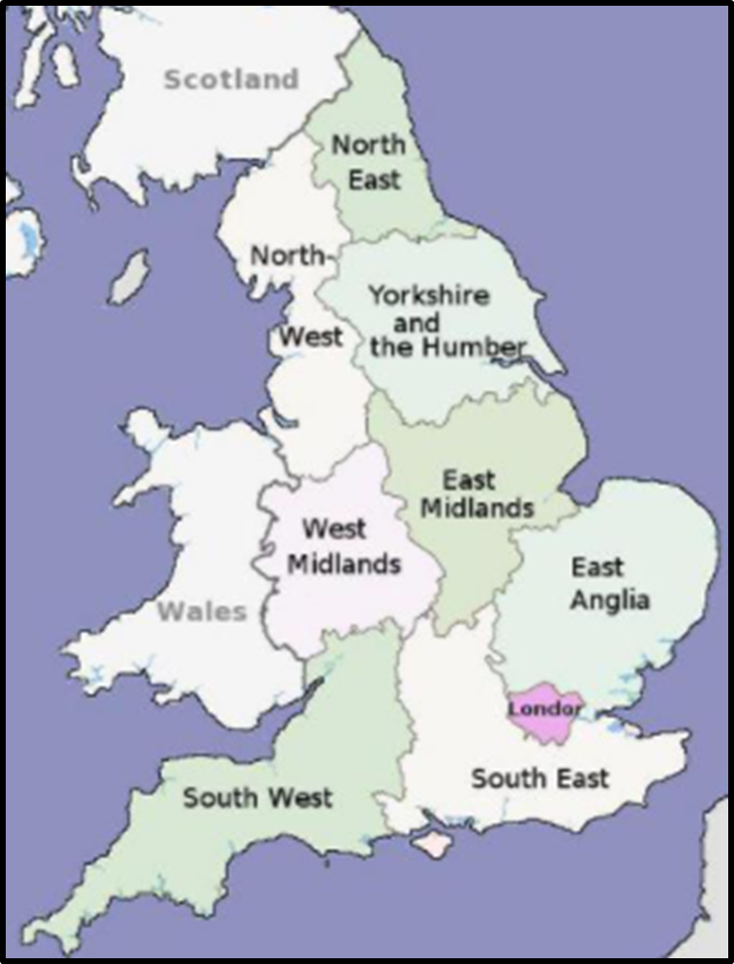
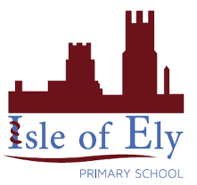
Geography Knowledge Organiser
Distant Counties and Regions

Key Vocabulary | Definition
Industry | Activity where raw materials are changed into goods that can be used and traded.
Arable farming | Farming where crops are planted, tended to and then harvested.
Pastoral farming | Farming where animals are raised and used for food or other produce such as wool.
Mining | Where a raw resource is extracted from the earth, for example, coal.
National Park | An area protected by laws to ensure land is preserved.
Viaduct | A type of bridge built across a valley to allow transport to cross from one side to another.
Valley | The low-lying land between mountains or hills.
Relief Map | A map showing the shape and height of land.
Population | The number of people living in a specific area.

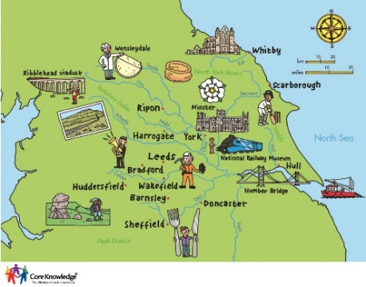
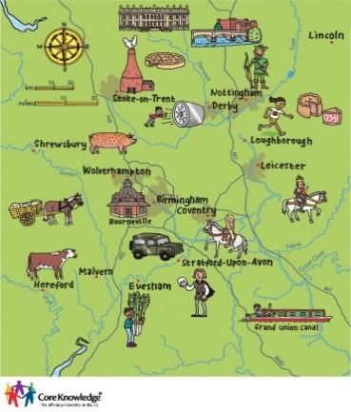
East Anglia
Yorkshire and Humberside
The Midlands

