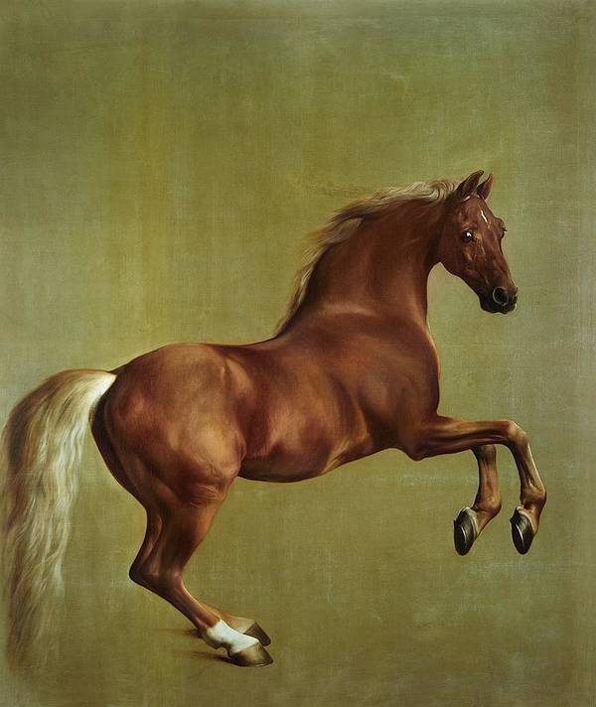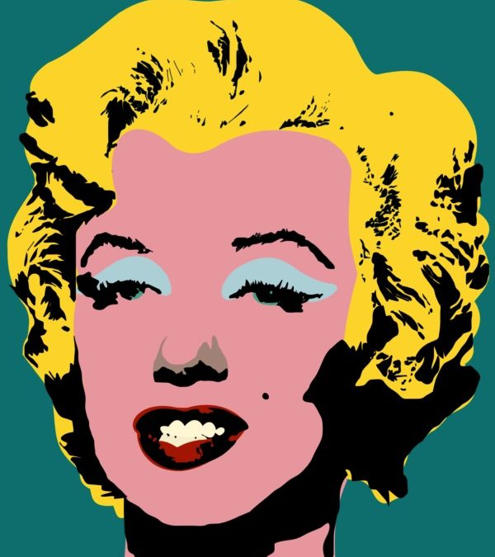

**Art Knowledge Organiser**

**Elements of Art: Style**

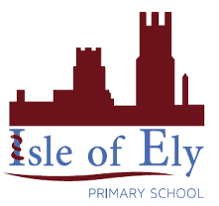

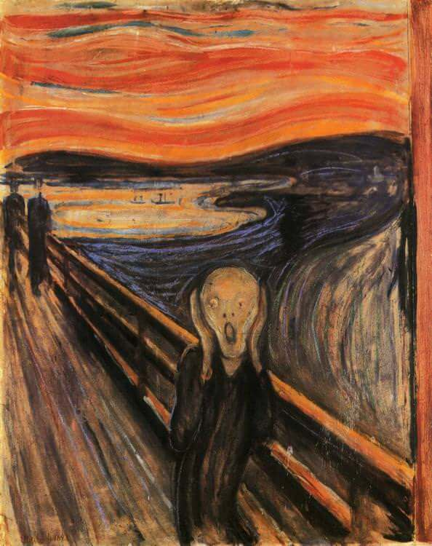

**Key Artists**

**George Stubbs Theo Von Doesburg**

**Edvard Munch** Marcel Breuer

Antoine Watteau

Thomas Chippendale

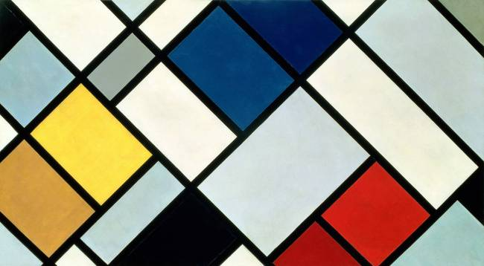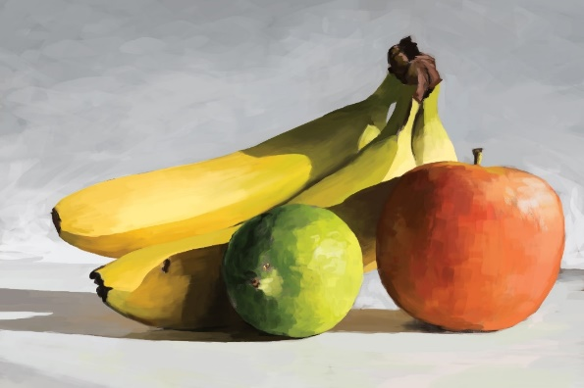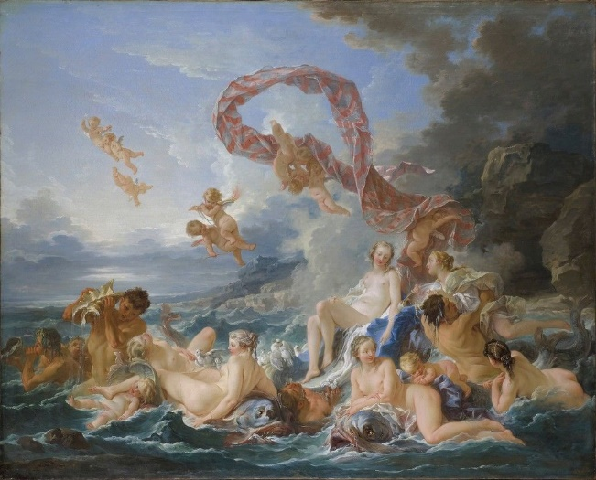

**Key Vocabulary:**

**Style** – how something looks.  
**Contrast** – difference between things.  
**Modernism** - was an art movement of the late 19th century to the mid-20th century that focused on new ways of doing old things.  
**Inanimate** – not having or showing characteristics associated with life.  
**Brushstroke** – the presentation given to paint by contact with the bristles of a brush.  
**Abstract** – A modern art which does not represent images of our everyday world.  
**Rococo** – An artistic style that is more playful and asymmetrical.  
**Still Life** – Is a work of art depicting mostly inanimate subject matter.