Vocabulary:
Colony/Colonist | A group of people from one country who build a settlement in another land.
Native American | The first people and cultures of the United States of America.
Taxation | Money paid to a government, which the government uses to pay for services to the people and to maintain itself.
Liberty | Freedom from control by another government.
Independence | Not having to depend on anyone or anything else.
Declaration | An act of formally or confidently stating something.
Independence Day | A holiday in the United States commemorating the Declaration of Independence on July 4, 1776.
Redcoats | A British soldier.
Minute Men | A member of a group who favoured independence of the American colonies and who were ready to fight at a minute's notice.
Learning Links:
Prior Learning: | Future Learning:
Rebel – Year 4  Charles I and the Civil War | Uprising – Year 6 Forming Alliances
Trade – Year 2 The Anglo Saxons to the Normans
Settle – Year 1 Discovering History | Settle - Year 6 Queen Victoria’s Widowed Reign
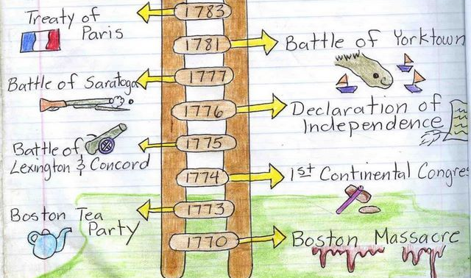
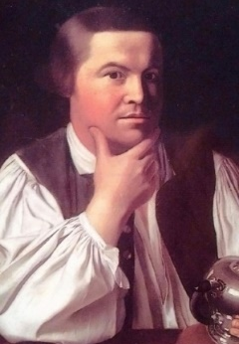
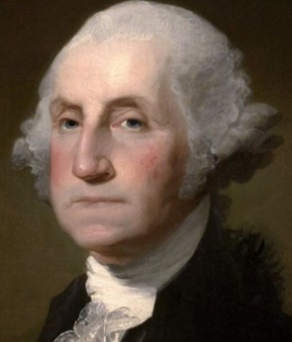
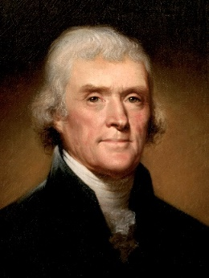
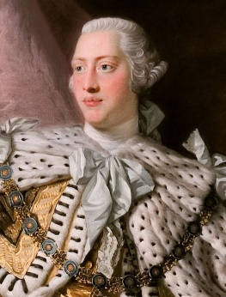
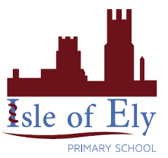
Timeline
George III
Thomas Jefferson
George Washington
Paul Revere
Unit: The American Revolution
Term: Spring B

