Primary Colours |  | Tints and Shades
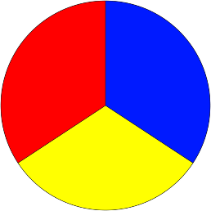  These are all part of a group called the primary colour.  The reason they are called primary colours is because you cannot make them with other colours. |  | A tint is a colour produced by adding white.  A shade is a colour produced by adding black.
Secondary Colours |  | Painting pictures of water.
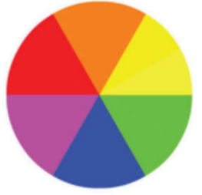  These are all part of a group called the secondary colours.  The reason they are called secondary colours is because you can mix them using the primary colours. |  | 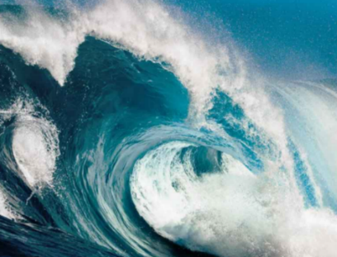  How many different shades or tints can you see?  How could you make these tints and shades using paint?
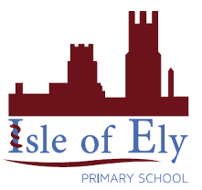
Knowledge Organiser
Autumn Term 1
Art – Elements of Art: Colour
Vocabulary
Primary | Colours we don’t mix – Red, yellow and blue.
Secondary | Colours mixed using primary colours – Purple, green and orange.
Mix | Putting two or more colours together
Tint | Colours we mix with white.
Shade | Colours we mix with black.
Gradually | A slow process.
Seascape | Picture of the sea

