What are the 5 different senses? |  | Our Body
Touch  Sight  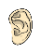Hearing  Smell  Taste |  | 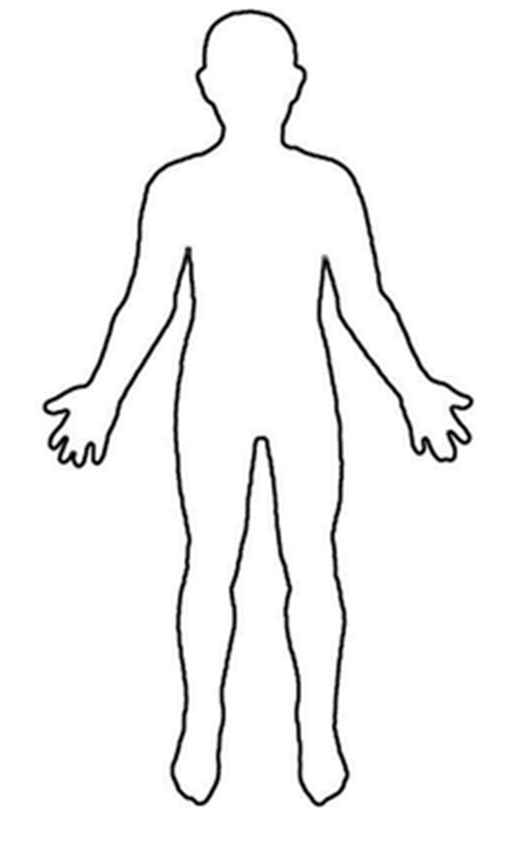  an you identify these body parts?  - Head  - Arm  - Leg  - Face  - Foot  - Hand  - Fingers  - Elbow
Which part of the body is associated with each sense? |  | Sensory impairment
Touch –> hands and feet  Sight –> eyes  Hearing –> ears  Smell –> nose  Taste –> mouth and tongue |  | Being blind means you cannot see.  Being deaf means you cannot hear.  What do you think might be difficult due to being blind or deaf?  Helen Keller showed how people can overcome sensory impairment. She demonstrated great perseverance and determination.
Knowledge Organiser
Autumn Term 1
Science – Body Parts and Senses
Vocabulary
senses | Our senses are what help us to understand and interact with the world we live in.
touch | Your skin gives you a sense of touch. So even when you are not looking you can tell if something is soft or rough or cold or hot.
sight | Your eyes are especially made to see what is around you. They make sure you can see things that are very close and far away. They need plenty of light to do it.
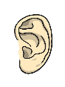  hearing | Your ears are especially designed to hear what is going on around you. Even when you are hearing lots of different things at once, your brain is very good at recognising the different sounds.
smell | Your nose is designed to detect smells. It can tell the difference between nice smells and nasty ones
taste | Your mouth and tongue give you your sense of taste so you can tell what tastes bitter to what is sweet.

