Power moves from the Monarchy to Parliament |  | Key Facts
- King John signed the Magna Carta which made promises to the English people.
- His son, Henry III, ignored the promises.
- This made the people angry and they formed a parliament and revolted against the king.
- Later, the Declaration of Rights was created which limited the power of Kings and Queens further.
Oliver Cromwell
Oliver was not a popular man. He banned all of these things…
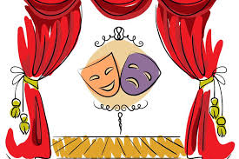
Knowledge Organiser
Summer Term 1
DT – Mechanisms: Wheels and Axles
Vocabulary
Accurate | Neat, correct shape, size and pattern with no mistakes.
Axle | A long straight rod which connects to a rotating part e.g. the wheels of a car.
Axle holder | The part of a mechanism which holds the axle steady.
Chassis | The body of a car.
Design | To make, draw or write plans for something.
Fix | To mend something so that it will work properly again.
Mechanic | A person who can build or mend vehicles or other machines.
Mechanisms | Parts of an object that move together to make something work.
Model | A practise version that lets you test out your idea and see how it will work and look.
Test | To find out whether something works as it should.
Wheel | A circular object that turns round. It can be fixed to a vehicle like a car or bicycle to allow the vehicle to move easily over the ground.

