Tally Chart |  | Branching Database
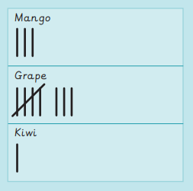 |  | 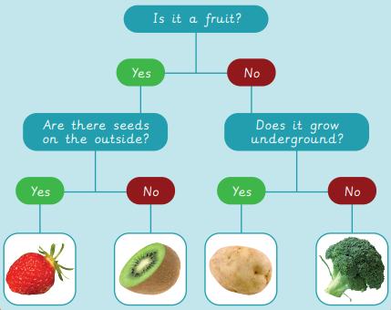  Line Graph Pictogram
Bar Graph
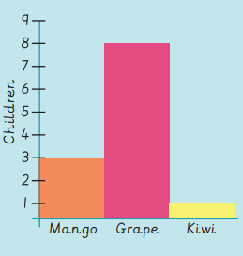
Knowledge Organiser
Summer Term 1
Computing – Introduction to Data
Vocabulary
Branching database | Using a series of yes or no questions to categorise data or objects.
Categorise | Put into groups that have similar or the same properties.
Chart | Information displayed in a graph, table, tally or diagram.
Computer | Electronic machine that accepts and processes information to produce an output, and then stores the results.
Data | Information used for a specific purpose or investigation.
Information | Facts about a specific thing, person, place or other.
Label | Information attached to something to tell you about it.
Pictogram | A chart which uses pictures to represent items.
Record | To store information about something.
Sort | To arrange items by an order or into a category.

