Power moves from the Monarchy to Parliament |  | Key Figures
- King John signed the Magna Carta which made promises to the English people.  - His son, Henry III, ignored the promises.  - This made the people angry and they formed a parliament and revolted against the king.  - Later, the Declaration of Rights was created which limited the power of Kings and Queens further. |  | 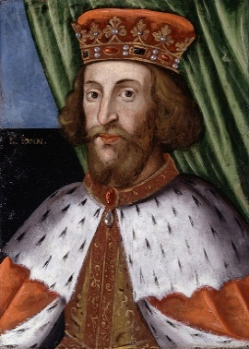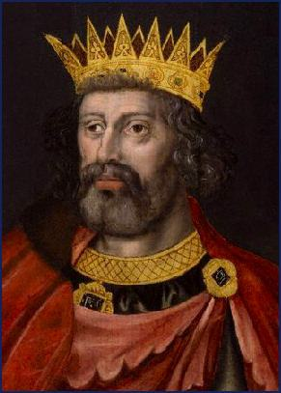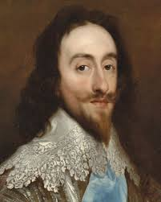  King John Henry III Charles I  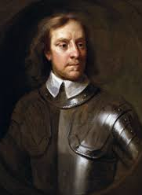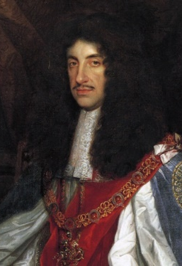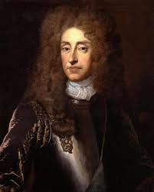  Oliver Cromwell Charles II James II  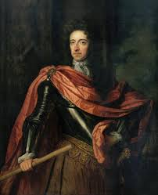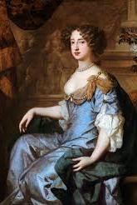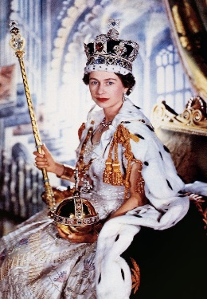  William II Mary II Elizabeth II
Oliver Cromwell
Oliver was not a popular man. He banned all of these things…
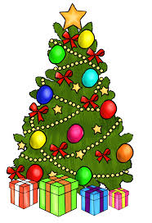
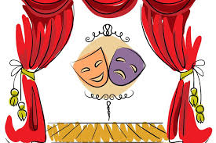
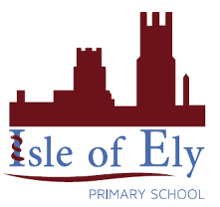
Knowledge Organiser
Summer Term 1
History – Kings and Queens
Vocabulary
Rule | Having power and authority over a group of people or an area
Barons | The lowest order of the British nobility and usually an important person
Reign | To rule as a monarch or the period of rule of a monarch
Tax | A compulsory contribution to government revenue
Parliament | Comprised of the monarch, the House of Lords and the House of Commons
Republic | A state which is run by an elected leader rather than a monarch
Restoration | The return of a monarch to the throne or a regime to power
Monarchy | A form of government with a monarch at the head of it
Rights | A moral or legal entitlement to have or do something
Overthrow | To forcibly remove someone or a government from power

