What plants need |  | Seeds | Plants we eat
What do plants need?  - Water  - Light  - Warmth  - A place to grow.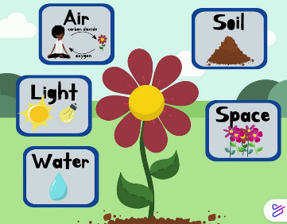  What happens if they don’t have these? |  | Let’s explore all the ways seeds spread:  - Wind  - Animals  - Water  - Humans  - Some seeds even explode.  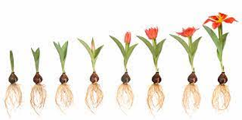 | We eat flowers, stems, leaves, fruits, seeds and roots from plants and call them edible.  Try and see if you have tried a vegetable from each part of a plant.
Parts of Plants |  | Deciduous and Evergreen
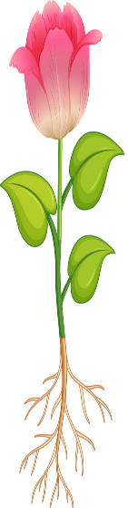  Roots – the part of a plant which attaches it to the ground.  Stem – the main body or stalk of a plant.  Leaves – a flattened structure of a higher plant which is attached to a stem or stalk.  Flower – the seed bearing part of a plant surrounded by bright coloured petals. |  | Evergreen – A plant that retains green leaves throughout the year.  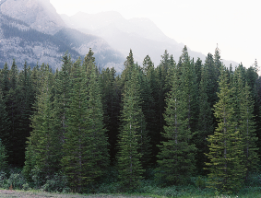  Deciduous – A plant that shreds its leaves annually (yearly).  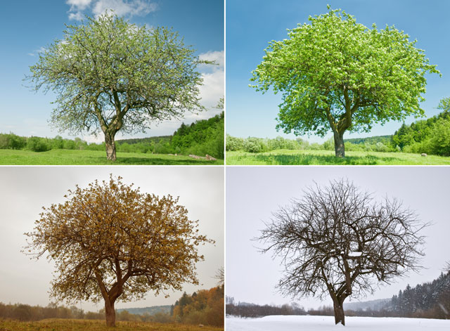
Knowledge Organiser
Summer Term 1
Science = Plants
Vocabulary
Plants | A living organism of some kind of tree, shrub, grass, fern, moss
Germinate | When a seed begins to grow.
Seeds | The unit of reproduction of a flowering plant
Anchor | Something that keeps something grounded.
Absorb | Take in or soak up something.
Disperse | Seed dispersal is the movement, spread or transport of seeds away from the parent plant.
Annual | Something that occurs once every year.
Nutrients | A substance that provides nourishment essential for the maintenance of life and for growth.
Edible | Something that is fit or suitable to be eaten.

