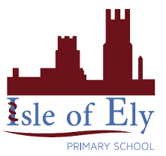
Knowledge Organiser
Year 2 - Autumn Term B
Vocabulary
Line | We will recall what straight, zigzag and curved lines are. We will experiment drawing these lines and focus on how holding our pencil effects our drawing.
Tactile texture | What an item actually feels like. We will describe real objects by using adjectives to describe what they feel like.
Visual texture | We will look at how artists use line to suggest a certain texture. We will practice creating visual texture using line.
Geometric shape | Squares, rectangles, triangles, circles and ovals are examples of geometric shapes. We will observe how they are found in natural items and in artwork.
Art – Elements of Art: Line, Texture and Shape

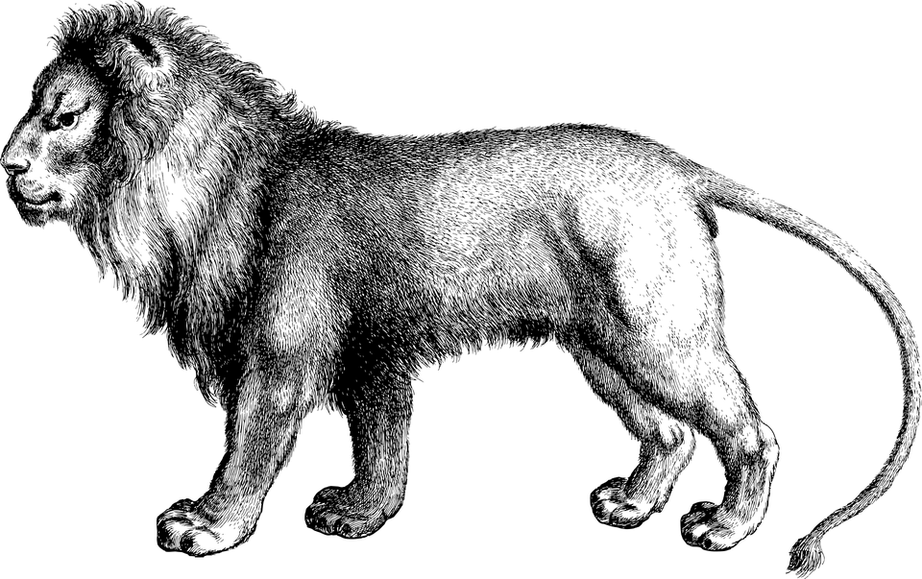
We will look at animal line drawings to discuss how visual texture is created.

We will look geometric shapes found in natural items and in artwork.
