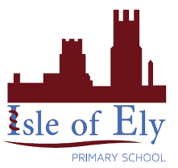
Knowledge Organiser
Year 2 - Autumn Term B
Vocabulary
Climate | The average weather conditions measured over years
Continent | A continent is a large solid area of land. Earth has seven continents.
Country | A country is land that is controlled by a single government
Cultural Symbols | A way of representing a place, such as a country, using a representation, e.g. a flag
Europe | Europe is one of the seven continents, one country within it is UK
Precipitation | Any liquid or frozen water that forms in the atmosphere and falls back to the Earth. It comes in many forms, like rain, sleet, and snow
UK | The United Kingdom, made up of England, Scotland, Wales and Northern Ireland,
Weather | Weather is day to day atmospheric conditions
Geography – The UK Geography, Weather and Climate

The United Kingdom

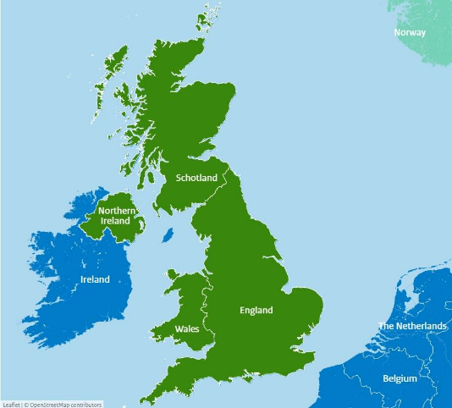
Can you spot any other countries in Europe?

Scotland

Symbols of the United Kingdom
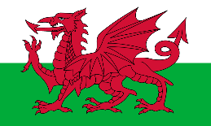
The same as the UK flag!
Wales
England
Northern Ireland
Scotland

