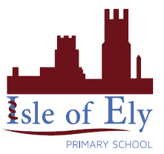
Knowledge Organiser
Material | Properties | Uses
Wood | Opaque, hard, strong | Door, chair
Glass | Transparent, waterproof | Window
Metal | Shiny, hard, smooth | Coin, fork
Plastic | Waterproof, transparent | Water bottle
Fabric | Stretchy, opaque | Clothes
Year 2 - Summer Term B
Vocabulary
Absorbent | Able to soak up liquid easily, like a sponge.
Brittle | Hard but can often be broken.
Materials | The substance used to make something, examples include glass, wood or metal.
Natural Materials | Natural materials are those that are found in nature and have not been made by humans,
Opaque | Not letting light pass through, the opposite of transparent
Properties | What a material or substance is like and how it behaves We can describe them using our five senses.
Recyclable Materials | Are materials which can be reused for other purposes, some materials are easier to recycle than others.
Transparent | Light can travel through it meaning that you can see what is on the other side of it.
Science – Suitability and Properties of Materials

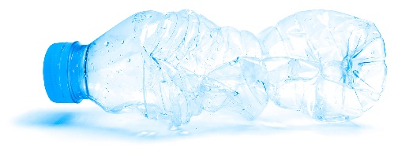

Suitability of Materials

Where have I come from?
