A Synagogue is a meeting place and studying place where Jewish people celebrate most of their festivals.
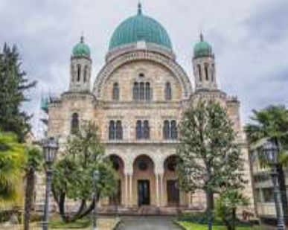

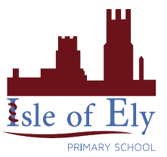
Knowledge Organiser
Year 2 - Autumn Term A
Vocabulary
Challah | A traditional plaited bread especially baked for Shabbat and other holidays
Chanukah | A Jewish holiday that lasts for eight nights
Commandments | Rules given by God that are mentioned in the Bible.
Holy | Dedicated to God; sacred
Maccabees | A group of Jewish people who rebelled against the King to get their holy temple back.
Moses | The prophet who led the Hebrew slaves out of Egypt.
Rosh Hashanah | The Jewish New Year.
Torah Scrolls | Are scrolls containing the entire text of the Five Books of Moses
The menorah is a special candelabrum with nine candles.
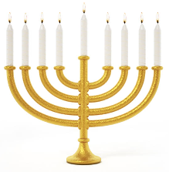

RE – Judaism: Beliefs
Shabbat is a day of rest and is held on the seventh day of the week (Saturday)
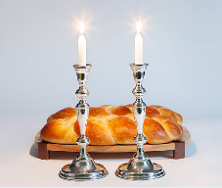

The Star of David
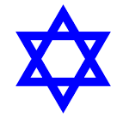

Kippah
