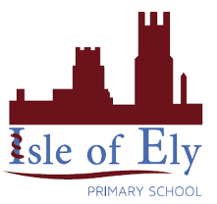
Knowledge Organiser
Year 2 – Autumn A
RE – Judaism - Beliefs
Vocabulary
Ark | A special chamber in the synagogue that houses the Torah scrolls
Commandments | Devine rules believed to be from god which Jewish people follow.
Chanukah | A Jewish festival lasting 8 days, which celebrates the recapture of Jerusalem from King Antiochus III
Judaism | A religion that is over 4000 years old and believes in one god.
Star of David | A symbol of special meaning to people of the Jewish faith.
Synagogue | In Judaism a synagogue is a place of worship and a place for learning.
Shabbat | Shabbat is the Jewish Day of Rest. Shabbat happens each week from sunset on Friday to sunset on Saturday
Torah Scroll | The Torah Scroll is an important holy text in Judaism and contains The 5 Books of Moses.

Jewish Symbols and Ceremonial Clothing
In different religions there are different symbols and items which are very important to the religion. In Judaism they include
