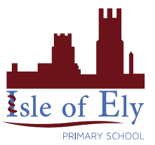
Knowledge Organiser
Year 2 - Autumn Term A
Art – Elements of Art: Colour
Vocabulary
The Colour Wheel | The colour wheel is used to help artists understand the relationship between colours.
Primary Colours | The primary colours are red, yellow and blue. They cannot be made by mixing other colours together. Other colours are made by mixing the primary colours.
Secondary Colours | The secondary colours are orange, green and purple. They are made by mixing equal amounts of two of the primary colours.
Warm Colours | The warm colours are red, orange and yellow.
Cool Colours | The cool colours are blue, purple and green.
Tint | A tint is made by adding white to a colour.
Shade | A shade is made by adding black to a colour.

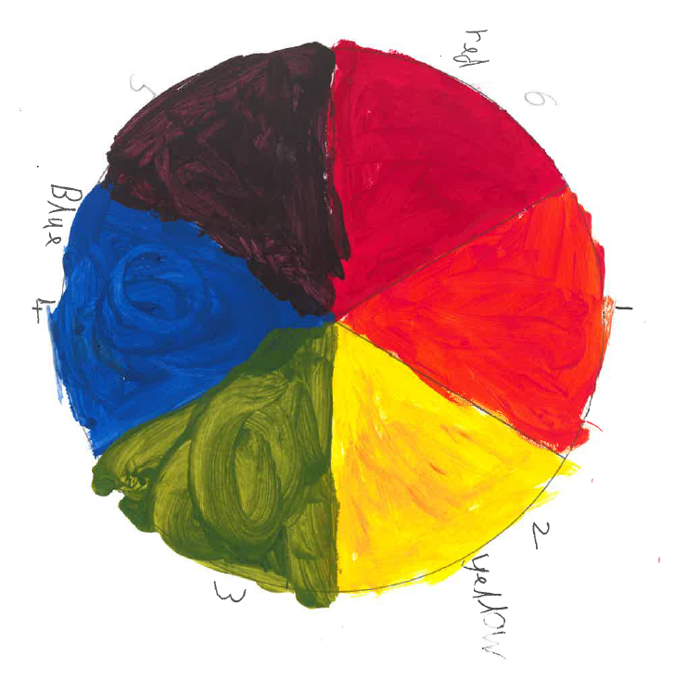

This half term we will recap our knowledge of colour from Year 1. We will revise the primary colours. We will build on this by learning about the secondary colours and presenting these using the colour wheel. The children will also revise their knowledge of tints and shades. The children will build on their understanding by looking at the use of colour in “The Beach at Trouville” by Claude Monet.

