Knowledge Organiser
Year 2 - Autumn Term A
Vocabulary
Alternative | Changing an ingredient to something different, for example using Almond milk instead of cows milk.
Diet | A food or drink that an animal or person usually drinks
Evaluation | When you look at the good and bad points of something, then think about how you could improve it
Expensive | Something that costs a lot of money
Healthy | When everything in your body and head feels good
Nutrients | Substances in food that all living things need to make energy, grow and develop.
Packaging | The packet or container, which holds a produce safe, ready to be sold.
Sugar | An ingredient which is used to make the food taste sweet.
Design Technology– A Balanced Diet

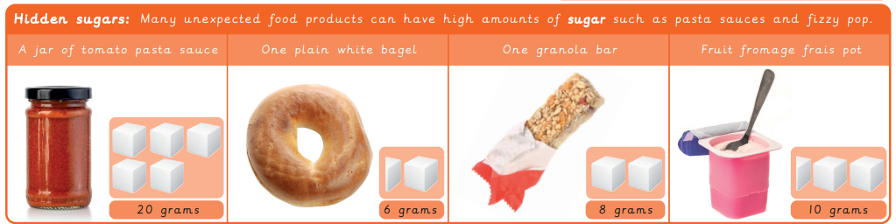

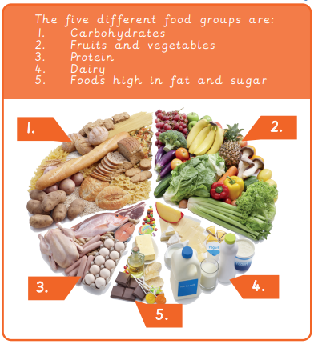
Key Facts

