Knowledge Organiser
Year 2 - Autumn Term A
Geography – Spatial Sense: The School Site
Vocabulary
Map | A map is a drawing of a particular area showing its main features as they would appear if you looked at them from above. Maps may include labels and symbols that give us more information.
Aerial photograph | Aerial photographs are photographs taken by planes or satellites.
Site | An area of ground used for a particular purpose.
Boundary | A line which marks the limits of an area; a dividing line.
Neighboring land | The land/area next to a piece of land.
Vegetation | Plants considered collectively, especially those found in a particular area or habitat.
Route | A way to travel.

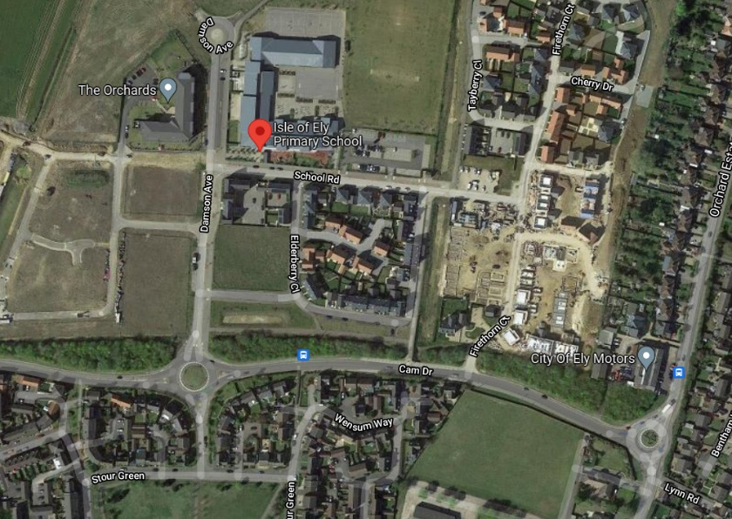

We will be looking at various maps and aerial photographs of the school site. The images below are taken from Google Maps and are two of the sources we will use in class.
