Knowledge Organiser
Ways to keep healthy | Reason
Exercise | Exercise keeps our muscles and bones strong. It also makes us feel happy.
Eating healthy foods | Our bodies take nutrients from our food that help us to grow and stay well.
Resting | Rest helps our bodies to recover and rebuild.
Keeping Clean | Good hygiene prevents germs from spreading.
Medicines | If we are ill, sometimes medicines can make us better.
Year 2 - Autumn Term A
Vocabulary
Skeleton | The bones that make up the human body
Joint | The place where two bones come together
Muscles | Muscles move the different parts of our body by contracting and relaxing
Digest | The process where the food we eat gets broken down
Red Blood Cell | Vehicles that carry oxygen around the body
Arteries | A tube that blood cells travel through around the body from the heart
Veins | A tube that carries blood cells back to the heart
Germs | Tiny little things that cause illness
Science – The Human Body

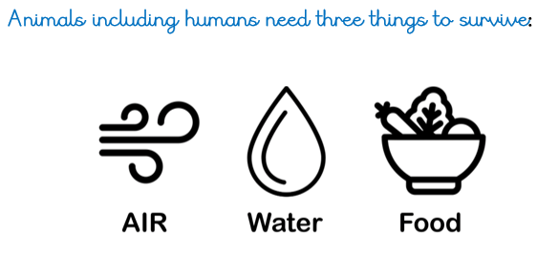

Keeping your body healthy

