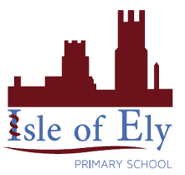
Knowledge Organiser
Year 2 - Autumn Term A

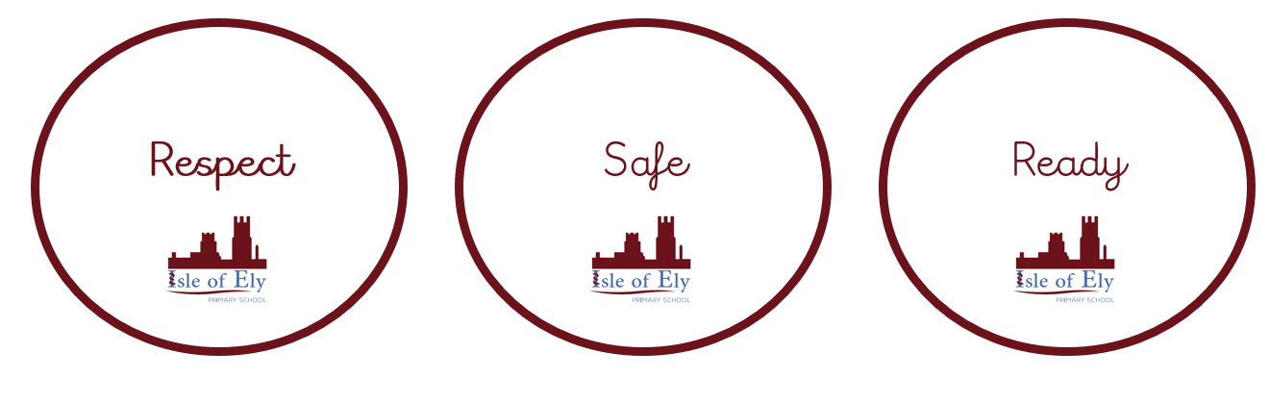
PSHE – Citizenship – Rights, rules and responsibilities
We will discuss what our school rules are and give examples of what they might look like. We will discuss why we have school rules and how they help. We will also discuss the responsibilities of adults and children at school.

We will start learning about democracy and the role of the school council at the Isle of Ely Primary School.

Vocabulary
Rule | Guidelines for how people should behave.
Responsibility | A job or duty.
Consequence | The result of a behaviour or action.
Benefit | A positive result of something happening.
Voting | A method of choosing.
School council | A group of pupils chosen to represent their school.

