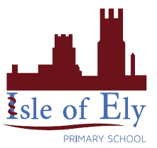Knowledge Organiser

Our new music topic is all about the British Isles.

The British Isles has 2 islands.

Two big islands that we call:

1. England, Scotland and Wales;
2. Ireland and Northern Ireland.

And about 6000 tiny islands, mostly off the coast of Scotland like Skye and the Hebrides, but also the Isle of Wight, Anglesey, Isle of Man, Lundy, Inishmore and Lindisfarne.



Throughout this unit you will sing and listen to music inspired by our country and making their own music about different parts of the British Isles.

Year 2 – Summer Term A

**Music– On this Island – British songs and sounds**

|  |  |
| --- | --- |
| **Key Vocabulary** | |
| Dynamics | Dynamics means how quietly or loudly a piece of music should be played. |
| Pitch | How high or low a sound is. |
| Tempo | The speed at which a piece of music should be played. |
| Structure | The order of the music. |
| Timbre | The quality of sound that makes one voice or instrument different from another. |
| Texture | How the different sounds are added together in a piece of music. |