Knowledge Organiser
Year 2 - Summer Term A
Geography – Northern Europe and the Globe

Key Vocabulary | Definition
Europe | One of the seven continents.
Scandinavia | The countries in northern Europe include: Denmark, Finland, Norway, Sweden and Iceland. These countries are often known together as Scandinavia.
Physical features of Northern Europe | 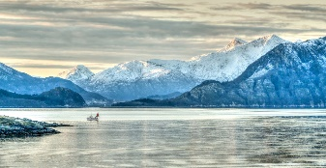  Examples of physical features include mountains, rivers and lakes. Northern Europe has some spectacular physical features such as snow-capped mountains, deep valleys and fjords. A fjord is a long and narrow inlet of sea, surrounded by steep cliffs created through the process of glacial erosion.  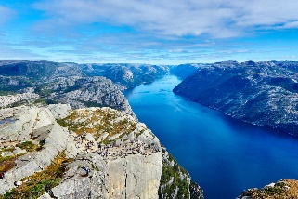
Human features of Northern Europe | Human features might include bridges, buildings, railways, canals or roads.
Key Vocabulary | Definition
Climate | Climate describes the weather conditions in a particular location over a prolonged period of time. The climate of northern Europe can be described as mild summers and cold winters. The climate is cooler in Northern Europe than in the United Kingdom.
Migration | Migration means movement from one place to another for a particular reason. Some animals in Northern Europe migrate a long way, some across continents. Other animals migrate on a much smaller scale, seeking warmer ground within a mountainous region for example.
Roald Amundsen | 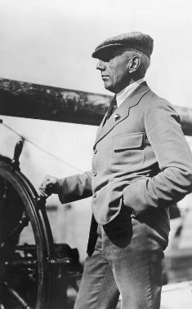  Roald Amundsen was born in 1872 into a wealthy family who owned ships. Amundsen decided to become an explorer and in 1903 he was the captain of the first ship to sail through an icy stretch of water called the Northwest Passage. The Northwest Passage connects the Atlantic and Pacific Oceans to the north of Canada.

