Knowledge Organiser
Year 2 - Spring Term B
Music– Dynamics, timbre, tempo and motifs

Key Vocabulary
Dynamics | Dynamics means how quietly or loudly a piece of music should be played.
Soundscape | A soundscape is made up of all of the different sounds that help to create a sense of place.
Tempo | The speed at which a piece of music should be played.
Motif | A short sequence of sounds.
Timbre | The quality of sound that makes one voice or instrument different from another.

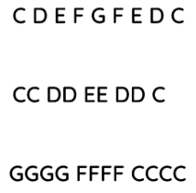
Motif shown in letter notation

Soundscape plan
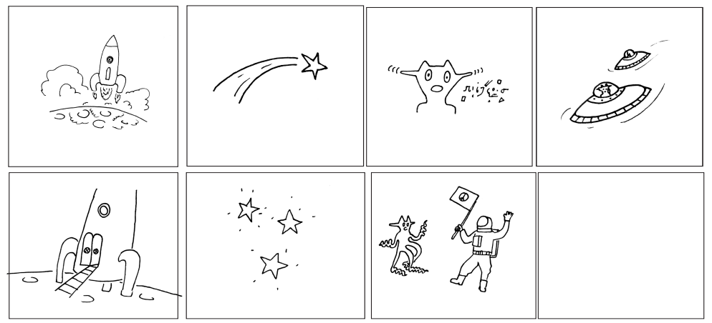
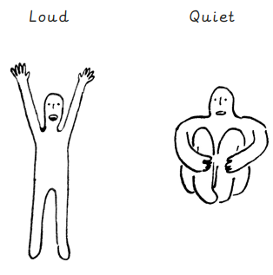
Dynamics – visual prompt

