Knowledge Organiser
Year 2 - Spring Term B
RE – Sikhism

Vocabulary
Sikhim | A religion founded in Punjab in the 15th century by Guru Nanak.
Guru | A Guru is a spiritual teacher. Sikhism has ten human gurus.
Guru Granth Sahib | Guru Granth Sahib is the Sikh holy book.
Kahalsa | A path that Sikhs who have been baptised and wear the five Ks follow. It was started by Guru Gobind Singh.
Gurdwara | A Gurdwara is the Sikh place of worship. Guru means teacher and dwara means door.
Sewa | Helping others in a variety of ways, without thinking of yourself.
In RE, we will be learning Sikhism. We will learn about the importance of the Sikh holy book and place of worship. We will learn about some of the key Sikh teachings and make comparisons with other religions they have learnt about previously.
Guru Granth Sahib
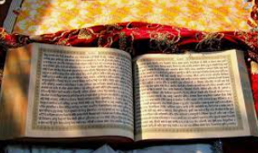

Gurdwara
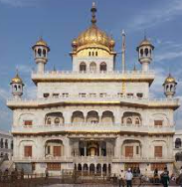

Symbol of Sikhism

