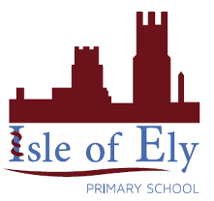
Knowledge Organiser
Year 2 - Spring Term B
Ancient Egyptian Art

Vocabulary
Ancient Egypt | An ancient civilisation which grew along the River Nile, in the country we now call Egypt.
Sphinx | A mythical creature with the head of a man and the body of a lion
The Great Sphinx | The Great Sphinx of Giza is a limestone statue of a reclining sphinx, a mythical creature that comprises a lion's body with a pharaoh's head.
Bust | A sculpture of a person’s head, shoulders and chest
The Bust of Nefertiti | A sculpture of a Queen Nefertiti’s head, shoulders and chest
meaning | Colours used in ancient Egyptian artwork may have meaning.

