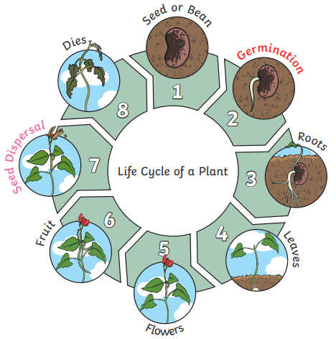
Knowledge Organiser
Year 2 - Spring Term B
Science – Plants
Key Vocabulary | Definition
germination | When the conditions are right, the seed soaks up water and swells, and the tiny new plant bursts out of its shell. This is called germination.
Shoot | A shoot grows upwards from the seed or plant to find sunlight
Seed dispersal | Seed dispersal is when the seeds move away from the parent plant. They can drop to the ground in the plant’s fruit or be moved by the wind or animals.
Sunlight | All plants need light from the sun to grow well. Some plants need lots of sunlight. Some plants only need a little sunlight.
Water | All plants need water to grow. Without water, seeds and bulbs will not germinate.
Temperature | Temperature is how warm or cold something or somewhere is. Some plants like cooler temperatures and some like warmer temperatures.
Nutrition | Food or nourishment. Plants make their own food in their leaves using sunlight.

