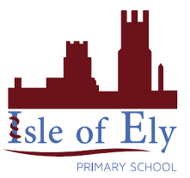
Knowledge Organiser
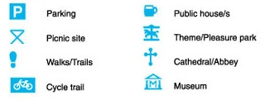
Year 2 - Summer Term A
Vocabulary
Map | A picture that shows where things are located.
Symbol | Small pictures that are used on maps to represent geographical features.
Boundrary | A line which marks the limit of an area.
Navigate | To plan and then travel along a route.
Route | How to get from your starting point to where you want to go.
Aerial | Viewing a place on a map from high above
Satellite Image | A picture taken from a satellite positioned in space
Address | How a places location on a map is written down, normally including a street name and house number.
Key | A box on a map that explains what symbols on a map mean
Geography – Spatial Sense: The School Site

Maps vs Aerial Photographs

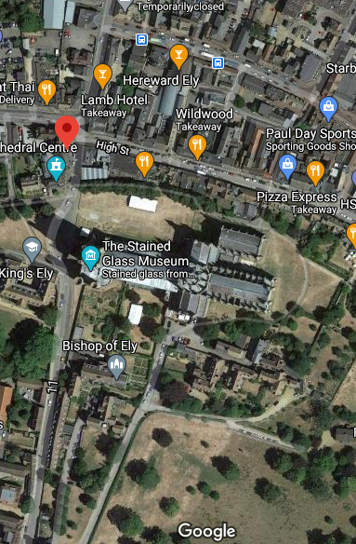
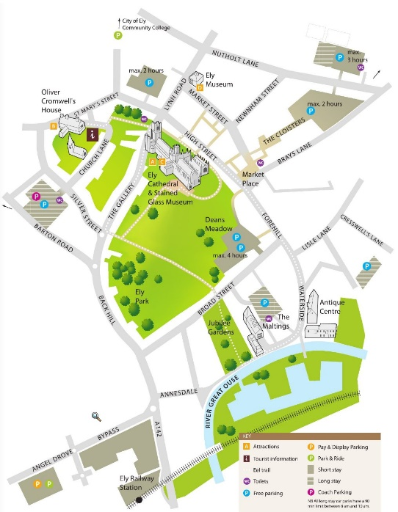

Aerial Photograph
Map

Common Map Symbols

