Knowledge Organiser
Year 2 - Summer Term A
Vocabulary
Exercise | Exercise means playing, being physically active and making our heart work harder than normal
Healthy | Being healthy means we look after our bodies, including our minds, muscles and bones. It also means that we are not ill.
Calm | Calm means we feel happy, relaxed and able to use our bodies how we wish.
Fitness | Fitness means being able to use our bodies to complete a number of tasks throughout the day. The fitter we become the more we can do without stopping.
Muscles | Muscles move the different parts of our body by  contracting and relaxing
Heart | The heart is a muscle that pumps blood around our bodies.
Hygiene | Hygiene is a collection of habits that we perform to keep themselves clean and their bodies healthy
Germs | Tiny living things that cause illness
Science – Importance of being healthy

Why should we be healthy?
- Being healthy makes us feel happy.
- It can make our bodies stronger, including our bones and muscles.
- It can help our body to recover, build and grow
- Demonstrating good hygiene can stop germs spreading and can stop us from getting ill.
- Sometimes we do get ill and medicines can help us recover and stay healthy.
Ways to keep healthy
Exercise  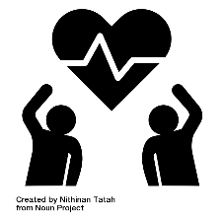 | Eating Healthy Foods  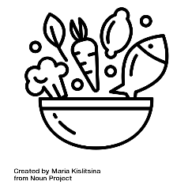 | Resting  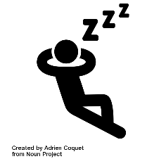
Example: running | Eating fruit and vegetables | Sleeping at night time
Keeping Clean  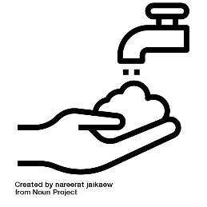 | Taking Medication  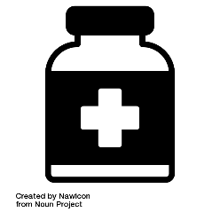 | Looking After our Minds  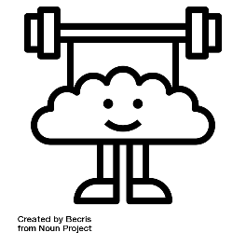
Example: washing hands | Cold tablets | Being kind to ourselves

