Knowledge Organiser
Year 4 – Summer Term A
Music: Samba and Carnival sounds and instruments
Vocabulary
Rhythm | A pattern of long and short sounds (and silences) within a piece of music.
Syncopation | A type of musical rhythm in which the strong notes are not on the beat.
Off-beat | The beats in between the ones you would naturally clap on.
Break | A four or eight beat rhythm, which is usually played once or twice.

Musical Style: Samba
Samba is a Brazilian music style which forms a part of everyday life in Brazil. It is used for celebrations, including the Rio Carnival, and even in football! It is a style of music which layers syncopated rhythms on multiple percussion instructions.

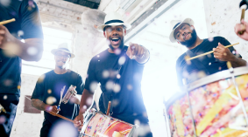

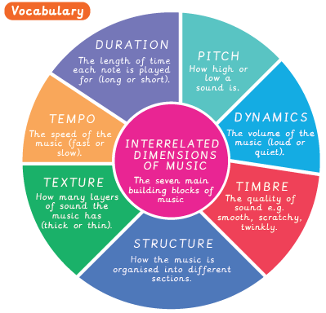
Untuned percussion:
Percussion instruments you cannot play a tune on.
