Vocabulary
Shadow | Areas that light does not reach.
Attention | Where the viewer’s eye is drawn, where the viewer focusses.
Mood | The feeling a picture represents, or makes the viewer feel.
Space | The use of areas on the canvas. Empty areas around the main object are called negative space.
Overlapping | When different objects in a picture are in the same space.
Foreground | Objects that appear nearer to the viewer are in the foreground.
Knowledge Organiser
Year 4 – Spring Term A
Important Artists work
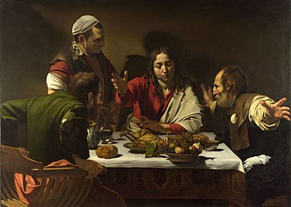
Supper at Emmaus, Caravaggio, 1601
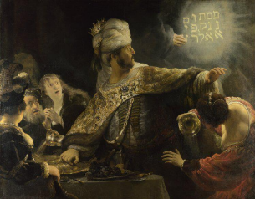
Belshazzar’s Feast, Rembrandt van Rijn, 1636
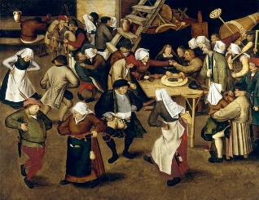
The Peasant Wedding, Pieter Bruegel the Younger, 1620
The Gleaners, Jean-Francois Millet, 1857
Art: Light and Space
Using Light
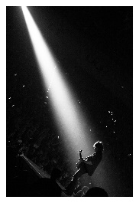 |  | 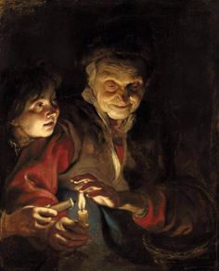 |  |  | 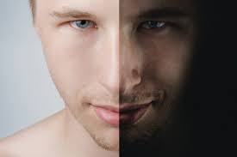
Artists use light and dark to focus the viewers’ attention. |  | Caravagggio contrasts dark shade with bright light – a style know as chiaroscuro. |  |  | Light can be used to create mood.
Illusion of Depth
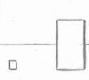 | 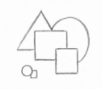 |  | 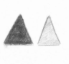 |  |  | 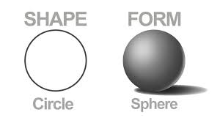
Size | Overlapping |  | Colour | Placement |  | Shading

