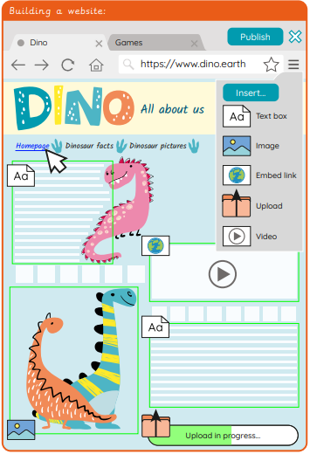
Knowledge Organiser
Year 4 – Spring 1
Computing – Web Design

Key Vocabulary | Definition
Collaboration | Working with others to achieve a special goal.
Content | All information and media contained in something, for example a webpage.
Create | To make something.
Design | To make, draw or write plans for something.
Edit | To change and amend something.
Embed | Media files which can be stored and viewed within a webpage.
Feature | The individual parts that make up something.
Header | Text at the top of the page.
Hyperlink | A link commonly used in web page or document, to direct you to another website or file.
Insert | To place a file into a web page or piece of software.
Online | When a person is accessing the internet through an electronic device.
Plan | An idea about how to do something in future.
Tab | A way of opening and organising multiple websites in a single window on an internet browser.
Web page | A hypertext page that can be viewed through an internet browser.
Website | A series of web pages and other content, which can be discovered and read through an internet browser, that all belong to a single domain name.
WWW | The acronym used to express the ‘World Wide Web’. It is found at the beginning of website addresses.
