Vocabulary
Aesthetic | How an object or product looks.
Cladding | A material put on top of another material for protection or to improve appearance.
Design criteria | A set of rules to help designers focus their ideas and measure the success of them.
Frame structure | A way of building something so that the inside supports are built first and the outside covering is added afterwards.
Pavilion | A decorative building or structure for leisure activities.
Reinforce | To make a structure or material stronger, especially by adding another material to it.
Stable | Object that does not topple over easily.
Target audience | A person or particular group of people who the product is aimed at.
Target customer | A person or particular group of people who you expect to buy the product.
Theme | An idea or specific design that your product or structure is based on (e.g. space themed).
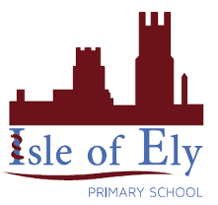
Knowledge Organiser
Year 4 – Spring Term A
Shapes for a frame structure
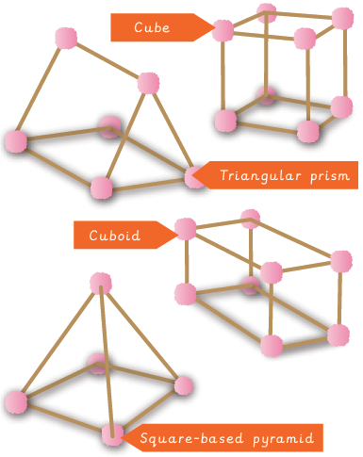
DT – Pavilions
Textures for cladding
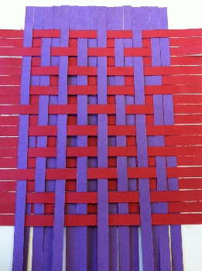 | 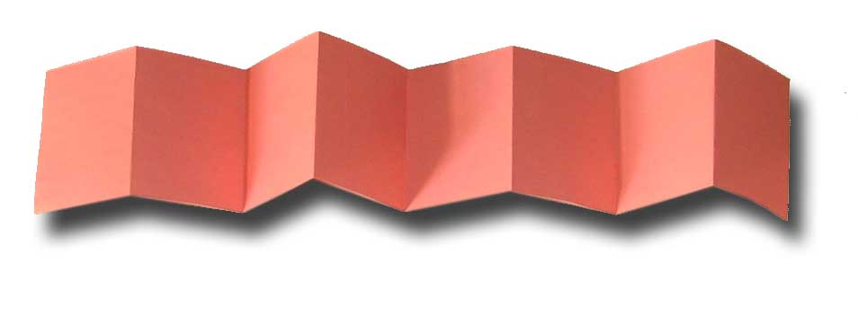 | 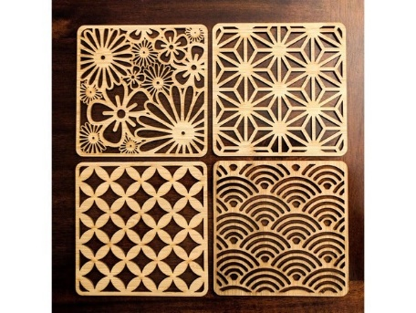
Weave | Concertina | Cut-outs

