Key Vocabulary | Definition
Electricity | Electricity is a form of energy. We can control it and use it.
Electrical current | The flow of electricity.
Electric shock | An electric shock occurs when electricity flows through a part of our body, it can be very dangerous. An electric shock from mains electricity can kills us.
Circuit | A path which electricity flows around.
Battery | A store of energy.
Light bulb | A component that converts electrical energy to light energy.
Switch | A component that can make or break an electrical circuit.
Wire | A thin piece of metal covered in plastic that conducts electricity.
Conductor | Materials that allow electricity to pass through them are called conductors.
Insulator | Materials that do not allow electricity to pass through are called insulators.
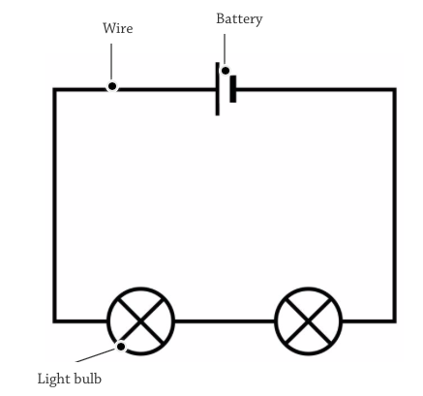
Knowledge Organiser- Science Year 6- Electricity

A series circuit has one path for electricity to flow.

AA Battery | Car Battery
1.5 V (Volts) | 12 V (Volts
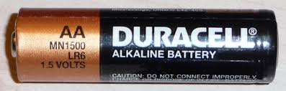 | 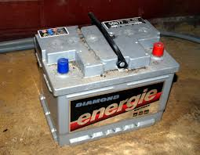

Electrical Symbols
Battery | Bulb | Wire | Switch

