|  |  |
| --- | --- |
| **Learning Links:** | |
| Prior Learning: | Future Learning: |
| Parliament – Reception (Rulers from around the world) | Ruler – Year 3  (Law and Power) |
| Union – Reception (Rulers from around the world) | Union – Year 4 (The Stuarts) |

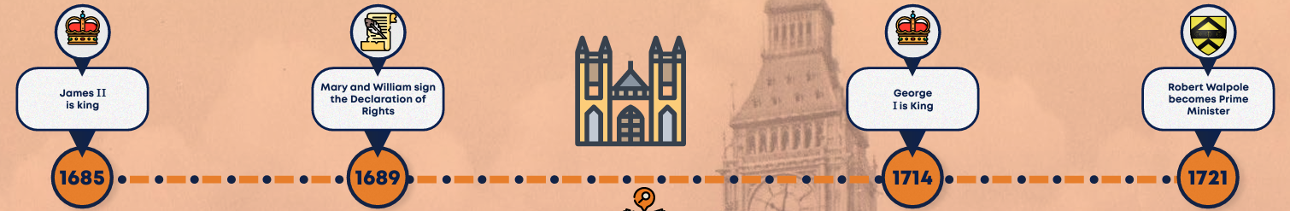

Parliament –

A group of people who make laws for their country.

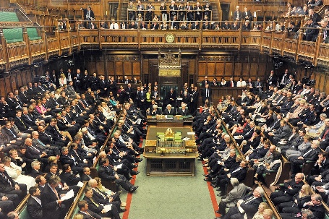

**Government**

Prime Minister –

The head of the government.



**Robert Walpole**

The first Prime Minister

**Rishi Sunak**

The current Prime Minister

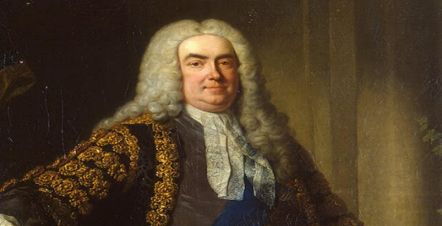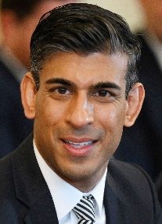

**Unit:** Parliament and Prime Ministers

**Term:** Summer 1

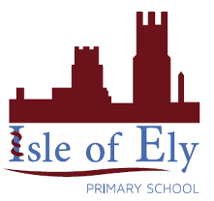

**Vocabulary**

Election

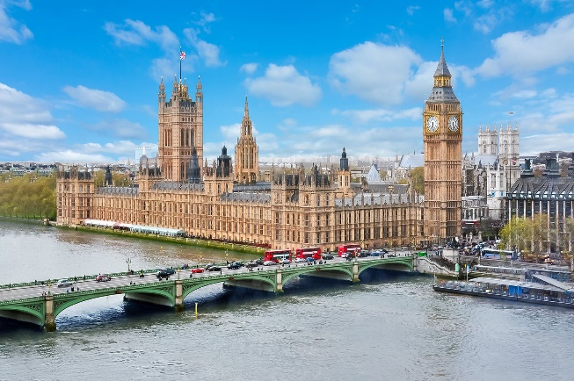

Houses of Parliament

Ballot Box

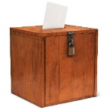

Polling station

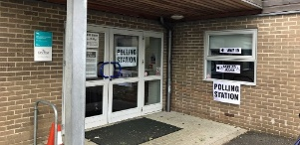

Vote – Choosing between two or more people.

