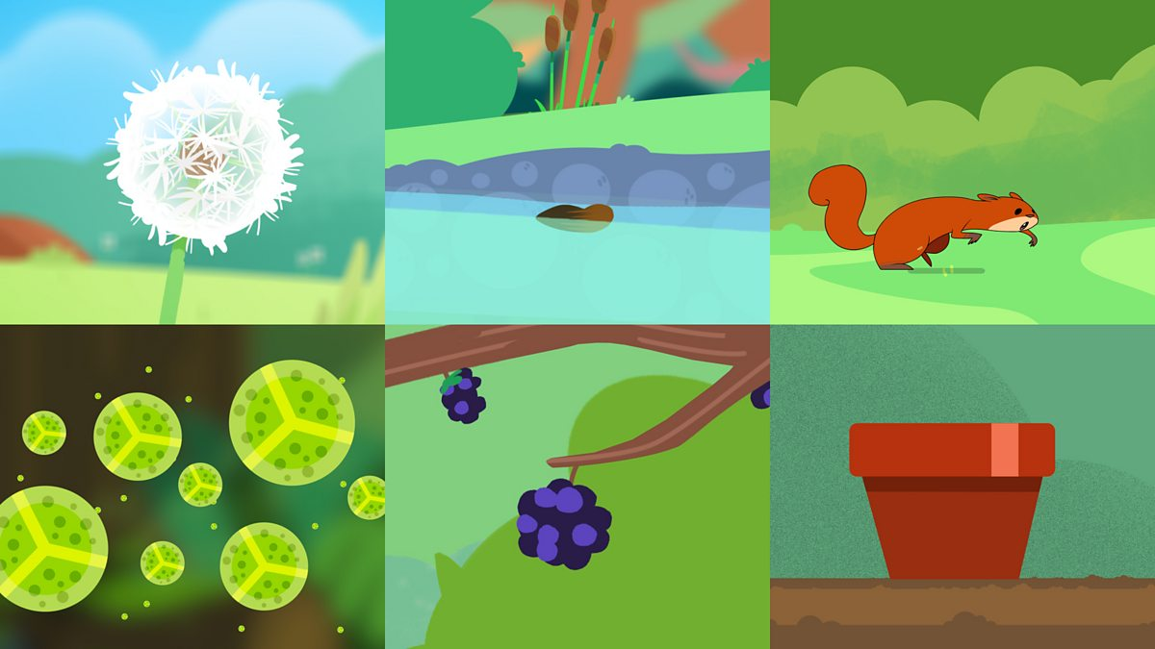

**Wind**

**Animals**

**Water**

**Humans**

**Exploding**

**How seeds spread**

**Unit:** Plants

**Term:** Summer 1



**What do plants need?**

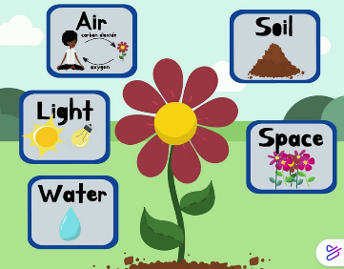

**Vocabulary**

**Seed**

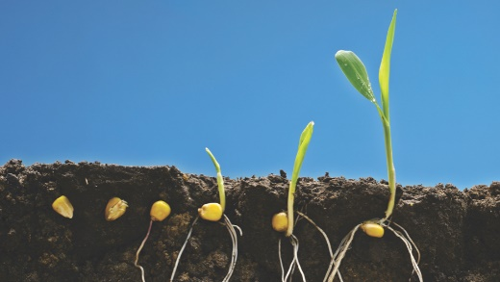

**Deciduous –** A tree that sheds its leaves in autumn.

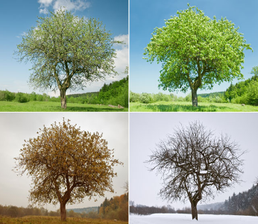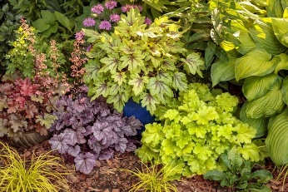

**Plant –** A living thing that grows in one place.

**Evergreen –** A tree that keeps its leaves in autumn.

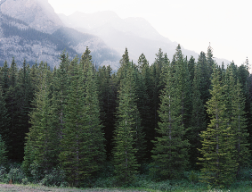

**Parts of a plant**

