**Executive Head Teacher’s Comment**

The children have had a lovely week throughout the school and all of the classes are happily learning and settled. Year 2 had a visit from the Dragon Hunters on Tuesday which enthused all of the children to write posters and stories which were wonderful. At one point, there was a Dragon loose in the school and the children were eagerly looking for it but I’m happy to say that it was recaptured! Year 1 thoroughly enjoyed their trip to Ely Museum and were great ambassadors for the school and Year 3/4 have been getting ready for their trip to the woods next week.

**ERIC** - you may have heard that name lately since we have all been exploring ERIC in our classes. ERIC stands for **E**veryone **R**eading **I**n **C**lass and is simply that! Every day (usually after lunch), we sit and read for no more than 15 minutes (some classes are building up to this) and it is an opportunity for everyone in class to read – including the teacher! Some children wish to bring in books from home, in addition to their banded reader, and that is fine (although please name). We simply want to help develop our awareness of reading for pleasure and encourage the children to share book recommendations, funny passages or brilliant illustrations. Fiction, non-fiction or poetry is all fine to share during this time since we simply want to celebrate reading and make sure it is given valuable time in our daily timetables.

You can support this focus on reading at home by showing how much you value the skill. Be a model and demonstrate how reading helps you in your daily life. Show how much you enjoy a book of your own. Also, please do not forget that reading is not just about decoding, it is the comprehension of a text and discussing the books your child is reading (or the one you are sharing together) which really makes the word come alive and sing off the page!

Thank you to all of the parents who attended our parent conversations this week, I hope you found them useful.

I wish you all an enjoyable weekend.

*Bryony Surtees*

**Dairy Dates**

**Wed 26th Sept**

Year 3 trip to Bewilderwood

**Wed 26th – Fri 28th Sept**

Year 4 Residential

**Fri 28th Sept @ 0830**

Parents’ Council Meeting

**Wed 3rd Oct @ 0830**

Years 1, 3 & 4 Parents’ Share Session (Writing)

**Thurs 4th Oct @ 0830**

Little Elvers, Reception & Year 2 Parents’ Share Session (Writing)

**Mon 8th Oct**

0845 Harvest Festival (Years 2, 3 & 4)

1430 Harvest Festival

(Little Elvers, Reception, Year 1)

**Thurs 11th Oct & Fri 19th Oct**

Open Session for Intake 19

**Fri 19th Oct**

Break up for half term

**Mon 29th Oct**

Back to School

***Big Talk***

*How would you capture a dragon?*

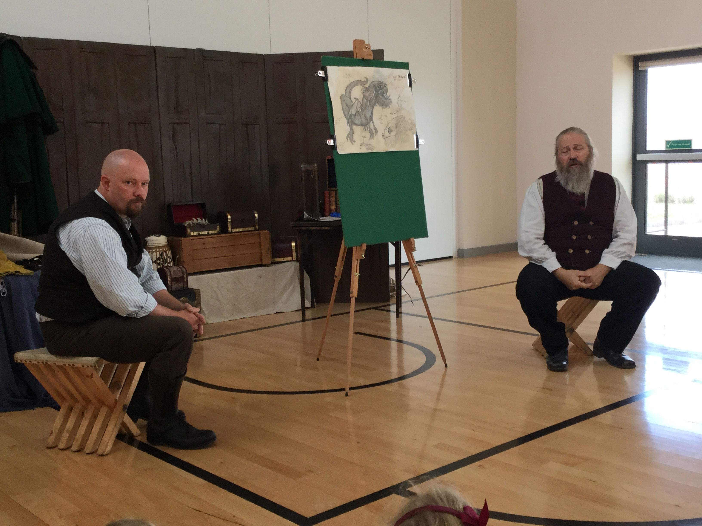

**Message from Caterlink:**

Are you looking for the ideal job to fit around school hours that is also term time only?

Caterlink, your school caterers have vacancies at the Isle of Ely and other schools within the area and we are looking to recruit people to join our team.

If you are interested in applying for the following vacancies please contact Kelly Newstead on 07392879312

*Kitchen Manager, Mobile Cook, General Assistant & Mobile Kitchen Assistant.*

**Year Group News**

**Reception**: What a fantastic week and well done to Reception for being independent and staying positive. This week we have been working on the Golden Rule, ‘We look after property’. The children had some great ideas for looking after property both inside and outside.  Thank you for sharing pictures of your families. Next week we will be working on the Golden Rule, ‘We work hard’. We would like the children to bring in items, photos or certificates that have made the children feel proud. This will link to our Big Question, ‘What makes you feel proud’. In literacy we will be continuing to look at rhyming words. Encourage your child to share their new rhyming words. We have been supporting the children’s early writing skills through play. In Maths we have been looking at different shapes, weights and patterns. The children have enjoyed creating funny shaped pictures! Thank you to those who attended parents’ evening. Just a reminder that Ladybird Class will continue with Forest School until half term and Butterfly Class with Outdoor Learning. Please remember wellies and coats are needed daily.

**Year 1:** Year One have had a great week. They really enjoyed learning about old and new toys at Ely Museum. Thanks to our parent helpers. In English the children have been reading Old Bear and thinking about characters feelings. They have also predicted what will happen next. In Maths we have continued to look at place value. The children have compared and ordered numbers. It would be great to practise 'one less' at home as this is something we have found tricky!

**Year 2:** Year two have had a fantastic week learning all about different dragons. We even got to see some dragon teeth and meet some real Dragon Hunters.  In Maths we have been learning systematic methods to partition two- digit numbers. All the children have tried very hard at this and have made us proud. Next week we will be recapping the names and properties of 2D shapes so please talk to your children about this over the weekend. In English we will be writing the end of our fantasy stories so please ask your children all about their story lines and encourage the description of characters and settings. In theme we will be looking at living, dead and never alive. PE will be on Monday and forest schools will be on Thursday.

**Year 3/4:** We have had a wonderful week writing our own 'Chiller' stories based in the woods. The children have been using fantastic powerful verbs and considering the impact their vocabulary has on the reader. In maths, the children have been comparing numbers and have been using the greater and less than signs. We have also been practising counting below 0.  We are all very excited about the trips next week. Please make sure you have completed the necessary paperwork for your child. Please can we also remind you that as the weather changes your child should come to school with appropriate clothing. Wasp and Earwig classes have PE on a Tuesday and Thursday and Grasshopper and Moth classes have PE on a Wednesday and Thursday. Please ensure they have their PE kits in school on these days

**Head teacher’s Award**

**Ladybird Class**

Finley G for super listening

**Butterfly Class**

Alex E for always trying hard

**Dragonfly Class**

Amelia C for aiming high with her challenge learning

**Bumblebee Class**

Georgia for aiming high and sharing her ideas on the carpet

**Caterpillar Class**

Fergus M for an excellent descriptive introduction to his story

**Spider Class**

Oliver B and Ollie B for their FANTASTIC writing

**Moth Class**

Harry C-U for being an excellent contributor to our Big Question discussions

**Wasp Class**

Alistair for demonstrating a positive approach to his learning

**Earwig Class**

Will B for making good choices and having a growth mindset

**Grasshopper Class**

Hannah C for putting maximum effort into her work