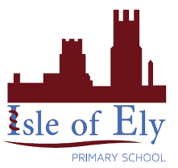
Knowledge Organiser
Year 2 - Spring Term B
Vocabulary
Islam | Islam is a very large religion that started in the 7th century
Mosque | A place of prayer and worship for Muslims
Mosaic | A picture or pattern produced by arranging together small pieces of stone, tile, glass, etc.
Ramadan | Is the ninth month of the Muslim calendar and observed by Muslims as a month of strict fasting, prayer, reflection and community.
Fasting | To not eat or drink anything
Pilgrimage | In Islam, this is a journey to Mecca that each Muslim is expected to make at least once in a lifetime.
5 Pillars | The most important Muslim practices that each Muslim must follow
RE – Islam: Beliefs
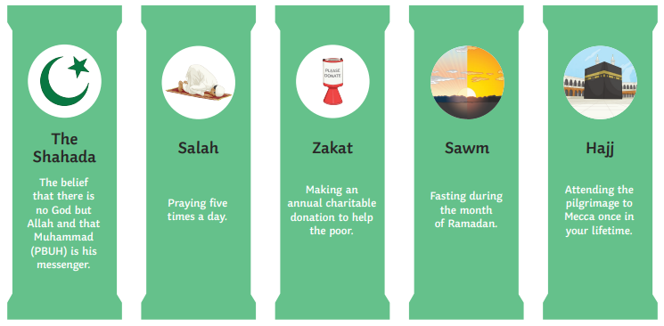

Mecca- the holiest city in Islam
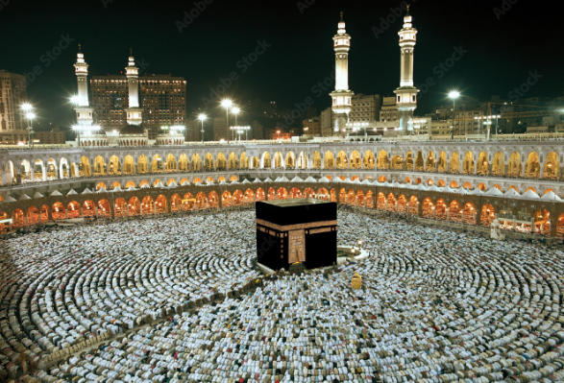
Mosque-a place of prayer for Muslims
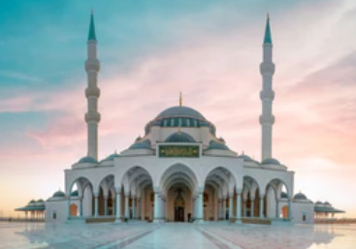
Hijri- a Islamic or Muslim lunar calendar 